UNITED STATES
SECURITIES AND EXCHANGE COMMISSION
Washington, D.C. 20549
FORM 8-K
CURRENT REPORT
Pursuant to Section 13 OR 15(d) of the
Securities Exchange Act of 1934
Date of Report (Date of earliest event reported): October 14, 2026
QUANTUM-SI INCORPORATED
(Exact name of registrant as specified in its charter)

Delaware |  |  | 001-39486 |  |  | 85-1388175
(State or other jurisdiction of incorporation) |  |  | (Commission File Number) |  |  | (IRS Employer Identification No.)
29 Business Park Drive
Branford, Connecticut |  |  |  |  |  | 06405
(Address of principal executive offices) |  |  |  |  |  | (Zip Code)
Registrant’s telephone number, including area code: (866) 688-7374
N/A
(Former name or former address, if changed since last report)

Check the appropriate box below if the Form 8-K filing is intended to simultaneously satisfy the filing obligation of the registrant under any of the following provisions:
o |  |  | Written communications pursuant to Rule 425 under the Securities Act (17 CFR 230.425)
o |  |  | Soliciting material pursuant to Rule 14a-12 under the Exchange Act (17 CFR 240.14a-12)
o |  |  | Pre-commencement communications pursuant to Rule 14d-2(b) under the Exchange Act (17 CFR 240.14d-2(b))
o |  |  | Pre-commencement communications pursuant to Rule 13e-4(c) under the Exchange Act (17 CFR 240.13e-4(c))
Securities registered pursuant to Section 12(b) of the Act:
Title of each class |  |  |  |  |  | Trading Symbol(s) |  |  |  |  |  | Name of each exchange on  which registered
Class A common stock, par value $0.0001 per share |  |  |  |  |  | QSI |  |  |  |  |  | The Nasdaq Stock Market LLC
Indicate by check mark whether the registrant is an emerging growth company as defined in Rule 405 of the Securities Act of 1933 (§230.405 of this chapter) or Rule 12b-2 of the Securities Exchange Act of 1934 (§240.12b-2 of this chapter).
Emerging growth company o
If an emerging growth company, indicate by check mark if the registrant has elected not to use the extended transition period for complying with any new or revised financial accounting standards provided pursuant to Section 13(a) of the Exchange Act. o

Item 8.01 Other Events.

As previously disclosed, on July 23, 2026, Quantum-Si Incorporated (the “Company”) received written notice (the “Notice”) from the Listing Qualifications Department (the “Staff”) of The Nasdaq Stock Market LLC (“Nasdaq”) notifying the Company that, because the closing bid price for the Company’s Class A common stock, par value $0.0001 per share (the “Common Stock”), had fallen below $1.00 per share for 30 consecutive business days, the Company no longer met the minimum bid price requirement for continued inclusion on The Nasdaq Global Market pursuant to Nasdaq Listing Rule 5450(a)(1) (the “Bid Price Requirement”), and that the Company had 180 days to regain compliance with the Bid Price Requirement.

On October 14, 2026, the Staff notified the Company that, as of October 13, 2026, the Company had regained compliance with the Bid Price Requirement and that the matter is now closed. The Company will continue to monitor the closing bid price of its Common Stock in the future. If the Company does not maintain compliance with Nasdaq Listing Rule 5450(a)(1) in the future, it is likely that Nasdaq will once again provide notice that the Company’s Class A common stock will be subject to delisting.
Also, on October 15, 2026, the Company issued a press release announcing that it regained compliance with Nasdaq’s continued listing requirements. A copy of the press release is attached as Exhibit 99.1 to this Current Report on Form 8-K and is incorporated herein by reference.

Item 9.01 Financial Statements and Exhibits.
(d)Exhibits.
Exhibit  No. |  |  |  |  |  | Description
99.1 |  |  |  |  |  | Press Release dated October 15, 2026
104 |  |  |  |  |  | Cover Page Interactive Data File (embedded within the Inline XBRL document)

SIGNATURES
Pursuant to the requirements of the Securities Exchange Act of 1934, the registrant has duly caused this report to be signed on its behalf by the undersigned hereunto duly authorized.
 |  |  | QUANTUM-SI INCORPORATED
 |  |  | By: |  |  | /s/ Jeffry Keyes
 |  |  | Name: |  |  | Jeffry Keyes
 |  |  | Title: |  |  | Chief Financial Officer
Date: October 15, 2026
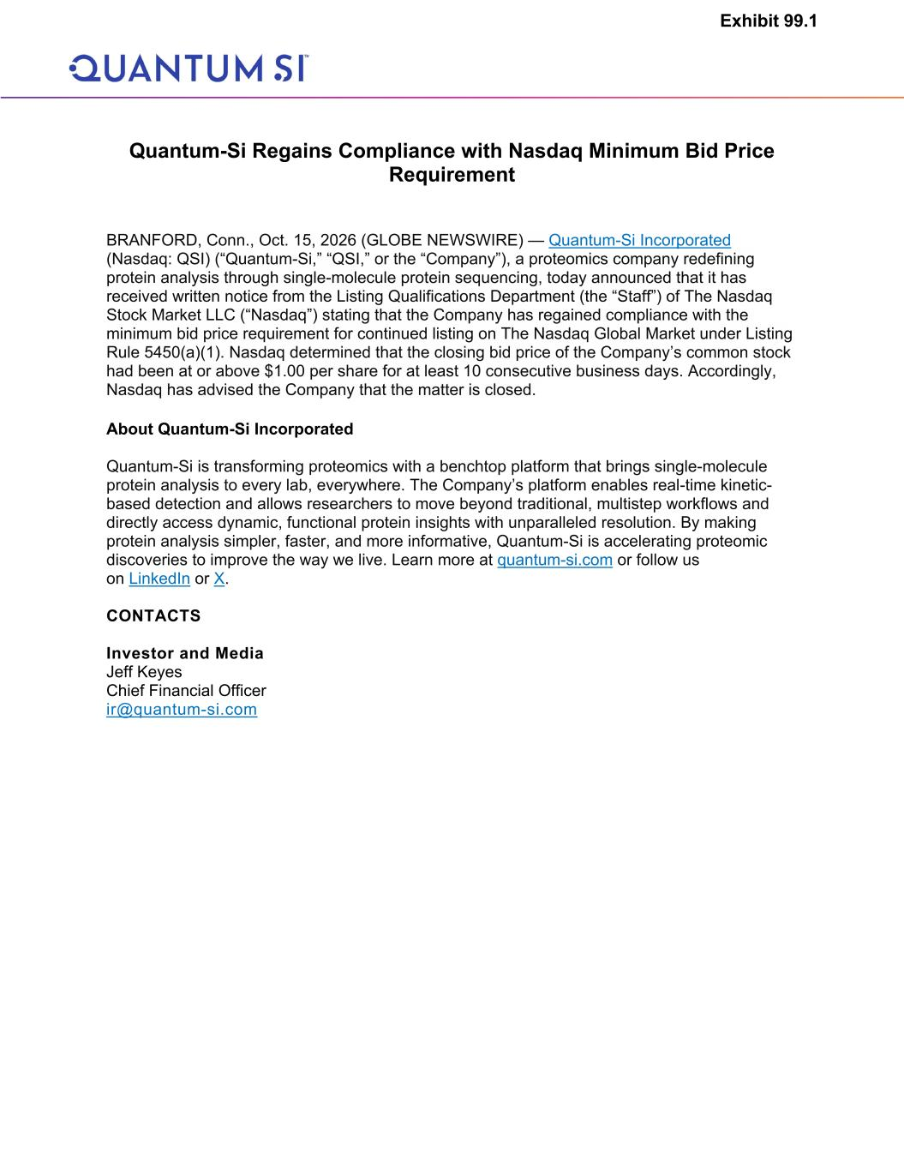

Quantum-Si Regains Compliance with Nasdaq Minimum Bid Price Requirement BRANFORD, Conn., Oct. 15, 2026 (GLOBE NEWSWIRE) — Quantum-Si Incorporated (Nasdaq: QSI) (“Quantum-Si,” “QSI,” or the “Company”), a proteomics company redefining protein analysis through single-molecule protein sequencing, today announced that it has received written notice from the Listing Qualifications Department (the “Staff”) of The Nasdaq Stock Market LLC (“Nasdaq”) stating that the Company has regained compliance with the minimum bid price requirement for continued listing on The Nasdaq Global Market under Listing Rule 5450(a)(1). Nasdaq determined that the closing bid price of the Company’s common stock had been at or above $1.00 per share for at least 10 consecutive business days. Accordingly, Nasdaq has advised the Company that the matter is closed. About Quantum-Si Incorporated Quantum-Si is transforming proteomics with a benchtop platform that brings single-molecule protein analysis to every lab, everywhere. The Company’s platform enables real-time kinetic- based detection and allows researchers to move beyond traditional, multistep workflows and directly access dynamic, functional protein insights with unparalleled resolution. By making protein analysis simpler, faster, and more informative, Quantum-Si is accelerating proteomic discoveries to improve the way we live. Learn more at quantum-si.com or follow us on LinkedIn or X. CONTACTS Investor and Media Jeff Keyes Chief Financial Officer ir@quantum-si.com Exhibit 99.1

