UNITED STATES
SECURITIES AND EXCHANGE COMMISSION
Washington, D.C. 20549
FORM 8-K
CURRENT REPORT
Pursuant to Section 13 OR 15(d) of the
Securities Exchange Act of 1934
Date of Report (Date of earliest event reported): September 28, 2026
QUANTUM-SI INCORPORATED
(Exact name of registrant as specified in its charter)

Delaware |  |  | 001-39486 |  |  | 85-1388175
(State or other jurisdiction of incorporation) |  |  | (Commission File Number) |  |  | (IRS Employer Identification No.)
29 Business Park Drive
Branford, Connecticut |  |  |  |  |  | 06405
(Address of principal executive offices) |  |  |  |  |  | (Zip Code)
Registrant’s telephone number, including area code: (866) 688-7374
N/A
(Former name or former address, if changed since last report)

Check the appropriate box below if the Form 8-K filing is intended to simultaneously satisfy the filing obligation of the registrant under any of the following provisions:
o |  |  | Written communications pursuant to Rule 425 under the Securities Act (17 CFR 230.425)
o |  |  | Soliciting material pursuant to Rule 14a-12 under the Exchange Act (17 CFR 240.14a-12)
o |  |  | Pre-commencement communications pursuant to Rule 14d-2(b) under the Exchange Act (17 CFR 240.14d-2(b))
o |  |  | Pre-commencement communications pursuant to Rule 13e-4(c) under the Exchange Act (17 CFR 240.13e-4(c))
Securities registered pursuant to Section 12(b) of the Act:
Title of each class |  |  |  |  |  | Trading Symbol(s) |  |  |  |  |  | Name of each exchange on  which registered
Class A common stock, par value $0.0001 per share |  |  |  |  |  | QSI |  |  |  |  |  | The Nasdaq Stock Market LLC
Indicate by check mark whether the registrant is an emerging growth company as defined in Rule 405 of the Securities Act of 1933 (§230.405 of this chapter) or Rule 12b-2 of the Securities Exchange Act of 1934 (§240.12b-2 of this chapter).
Emerging growth company o
If an emerging growth company, indicate by check mark if the registrant has elected not to use the extended transition period for complying with any new or revised financial accounting standards provided pursuant to Section 13(a) of the Exchange Act. o

Item 7.01 Regulation FD Disclosure.

From time to time, Quantum-Si Incorporated (the “Company”) presents and/or distributes slides and presentations to the investment community to provide updates and summaries of its business. On September 28, 2026, the Company issued a press release and posted to its website a presentation used at World HUPO 2026 in Singapore on September 29, 2026 at 12:15 p.m. SGT. The presentation slides are available on the “Investors” section of the Company’s website at https://ir.quantum-si.com. This presentation is also furnished as Exhibit 99.1 to this Current Report on Form 8-K.

The information in this Item 7.01, including Exhibit 99.1, is being furnished and shall not be deemed “filed” for purposes of Section 18 of the Securities Exchange Act of 1934, as amended (the “Exchange Act”), or otherwise subject to the liabilities of that Section, nor shall it be deemed incorporated by reference into any registration statement or other filing under the Securities Act of 1933, as amended, or the Exchange Act, except as shall be expressly set forth by specific reference in such filing. The furnishing of the information in this Item 7.01 and Exhibit 99.1 is not intended to, and does not, constitute a determination or admission by the Company that the information in this report is material or complete, or that investors should consider this information before making an investment decision with respect to any security of the Company or any of its affiliates.

Forward-looking Statements

Certain information discussed in this Current Report on Form 8-K is forward-looking information that involves risks, uncertainties and assumptions. Forward-looking statements may be identified by words such as “anticipate,” “believe,” “condition,” “expect,” “if,” “intend,” “may,” “will,” “planned” and similar expressions. Forward-looking statements involve known and unknown risks and uncertainties that may cause our actual plans or results to differ from our assumptions or expectations. Our risks are more fully described in our filings with the Securities and Exchange Commission, including our most recently filed Annual Report on Form 10-K, as updated in subsequently filed Quarterly Reports on Form 10-Q, as applicable. Forward-looking statements speak only as of the date they are made, and we expressly disclaim any obligation to update any forward-looking information.

Item 9.01 Financial Statements and Exhibits.
(d)Exhibits.
Exhibit  No. |  |  |  |  |  | Description
99.1 |  |  |  |  |  | Quantum-Si World HUPO 2026 Presentation dated September 28, 2026
99.2 |  |  |  |  |  | Press release dated September 28, 2026
104 |  |  |  |  |  | Cover Page Interactive Data File (embedded within the Inline XBRL document)

SIGNATURES
Pursuant to the requirements of the Securities Exchange Act of 1934, the registrant has duly caused this report to be signed on its behalf by the undersigned hereunto duly authorized.
 |  |  | QUANTUM-SI INCORPORATED
 |  |  | By: |  |  | /s/ Jeffry Keyes
 |  |  | Name: |  |  | Jeffry Keyes
 |  |  | Title: |  |  | Chief Financial Officer
Date: September 28, 2026
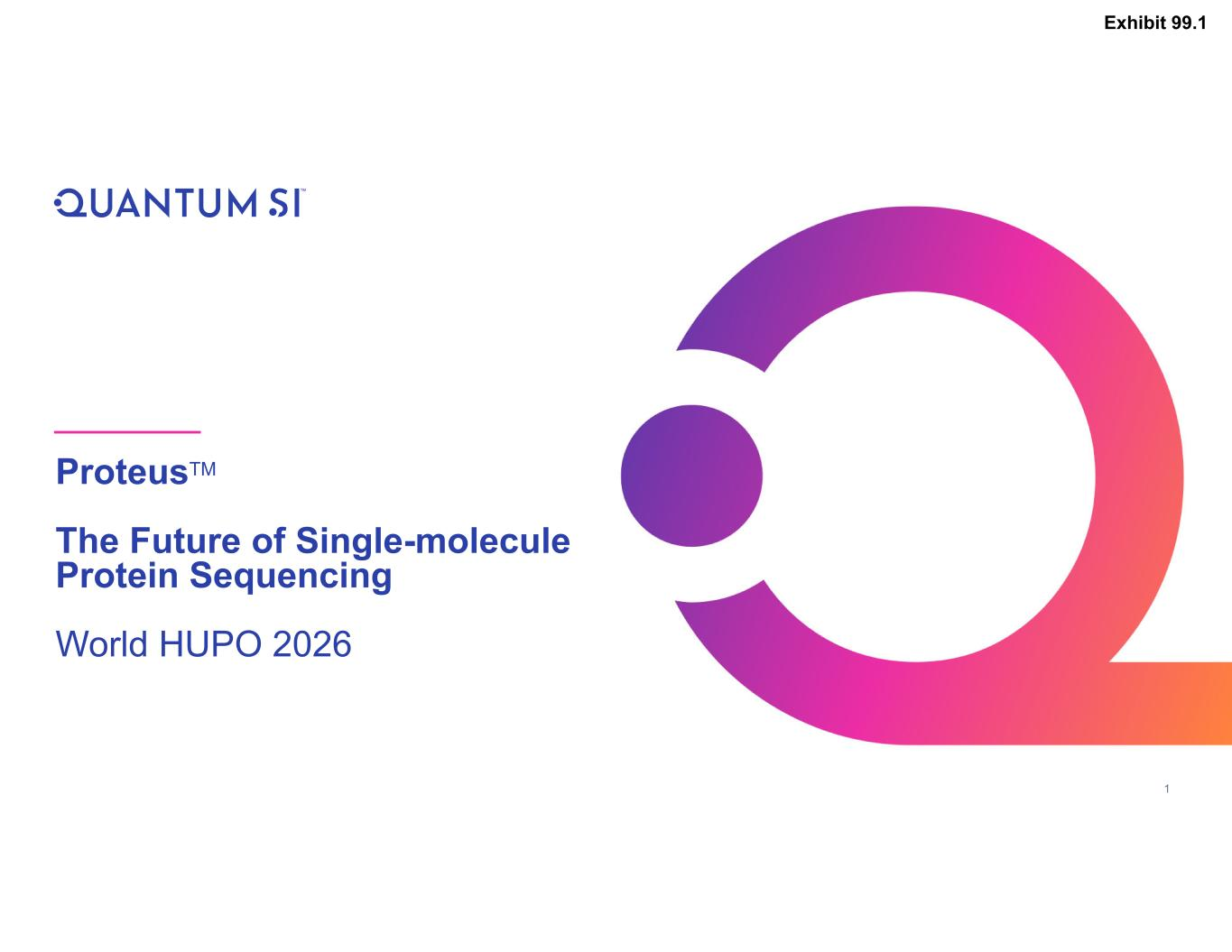

1 ProteusTM The Future of Single-molecule Protein Sequencing World HUPO 2026 Exhibit 99.1

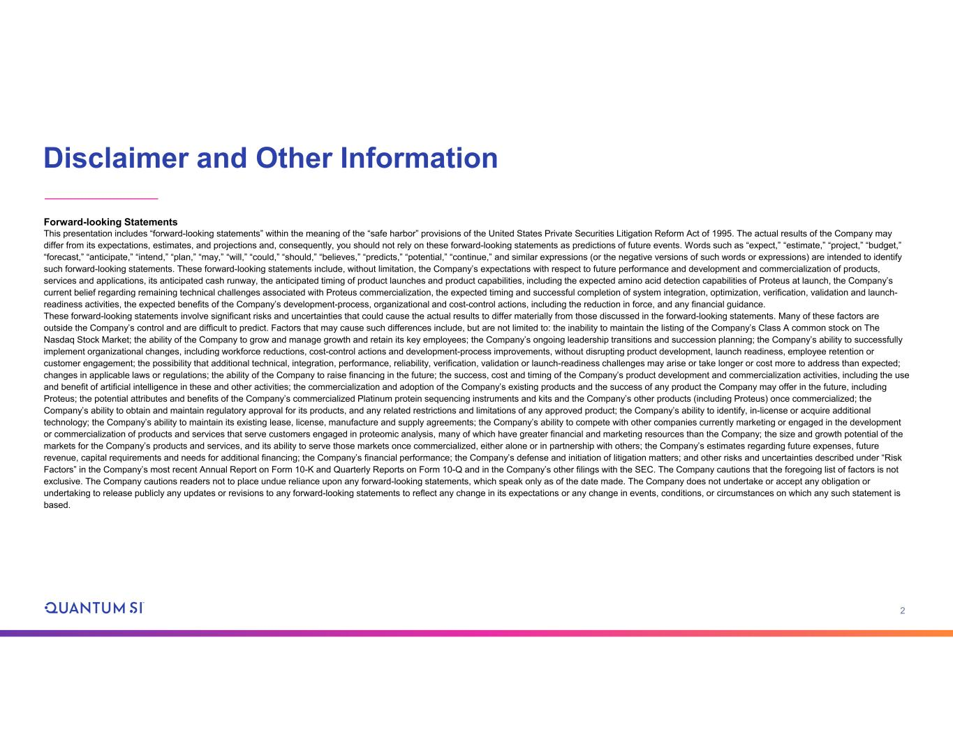
2 Disclaimer and Other Information Forward-looking Statements This presentation includes “forward-looking statements” within the meaning of the “safe harbor” provisions of the United States Private Securities Litigation Reform Act of 1995. The actual results of the Company may differ from its expectations, estimates, and projections and, consequently, you should not rely on these forward-looking statements as predictions of future events. Words such as “expect,” “estimate,” “project,” “budget,” “forecast,” “anticipate,” “intend,” “plan,” “may,” “will,” “could,” “should,” “believes,” “predicts,” “potential,” “continue,” and similar expressions (or the negative versions of such words or expressions) are intended to identify such forward-looking statements. These forward-looking statements include, without limitation, the Company’s expectations with respect to future performance and development and commercialization of products, services and applications, its anticipated cash runway, the anticipated timing of product launches and product capabilities, including the expected amino acid detection capabilities of Proteus at launch, the Company’s current belief regarding remaining technical challenges associated with Proteus commercialization, the expected timing and successful completion of system integration, optimization, verification, validation and launch- readiness activities, the expected benefits of the Company’s development-process, organizational and cost-control actions, including the reduction in force, and any financial guidance. These forward-looking statements involve significant risks and uncertainties that could cause the actual results to differ materially from those discussed in the forward-looking statements. Many of these factors are outside the Company’s control and are difficult to predict. Factors that may cause such differences include, but are not limited to: the inability to maintain the listing of the Company’s Class A common stock on The Nasdaq Stock Market; the ability of the Company to grow and manage growth and retain its key employees; the Company’s ongoing leadership transitions and succession planning; the Company’s ability to successfully implement organizational changes, including workforce reductions, cost-control actions and development-process improvements, without disrupting product development, launch readiness, employee retention or customer engagement; the possibility that additional technical, integration, performance, reliability, verification, validation or launch-readiness challenges may arise or take longer or cost more to address than expected; changes in applicable laws or regulations; the ability of the Company to raise financing in the future; the success, cost and timing of the Company’s product development and commercialization activities, including the use and benefit of artificial intelligence in these and other activities; the commercialization and adoption of the Company’s existing products and the success of any product the Company may offer in the future, including Proteus; the potential attributes and benefits of the Company’s commercialized Platinum protein sequencing instruments and kits and the Company’s other products (including Proteus) once commercialized; the Company’s ability to obtain and maintain regulatory approval for its products, and any related restrictions and limitations of any approved product; the Company’s ability to identify, in-license or acquire additional technology; the Company’s ability to maintain its existing lease, license, manufacture and supply agreements; the Company’s ability to compete with other companies currently marketing or engaged in the development or commercialization of products and services that serve customers engaged in proteomic analysis, many of which have greater financial and marketing resources than the Company; the size and growth potential of the markets for the Company’s products and services, and its ability to serve those markets once commercialized, either alone or in partnership with others; the Company’s estimates regarding future expenses, future revenue, capital requirements and needs for additional financing; the Company’s financial performance; the Company’s defense and initiation of litigation matters; and other risks and uncertainties described under “Risk Factors” in the Company’s most recent Annual Report on Form 10-K and Quarterly Reports on Form 10-Q and in the Company’s other filings with the SEC. The Company cautions that the foregoing list of factors is not exclusive. The Company cautions readers not to place undue reliance upon any forward-looking statements, which speak only as of the date made. The Company does not undertake or accept any obligation or undertaking to release publicly any updates or revisions to any forward-looking statements to reflect any change in its expectations or any change in events, conditions, or circumstances on which any such statement is based.

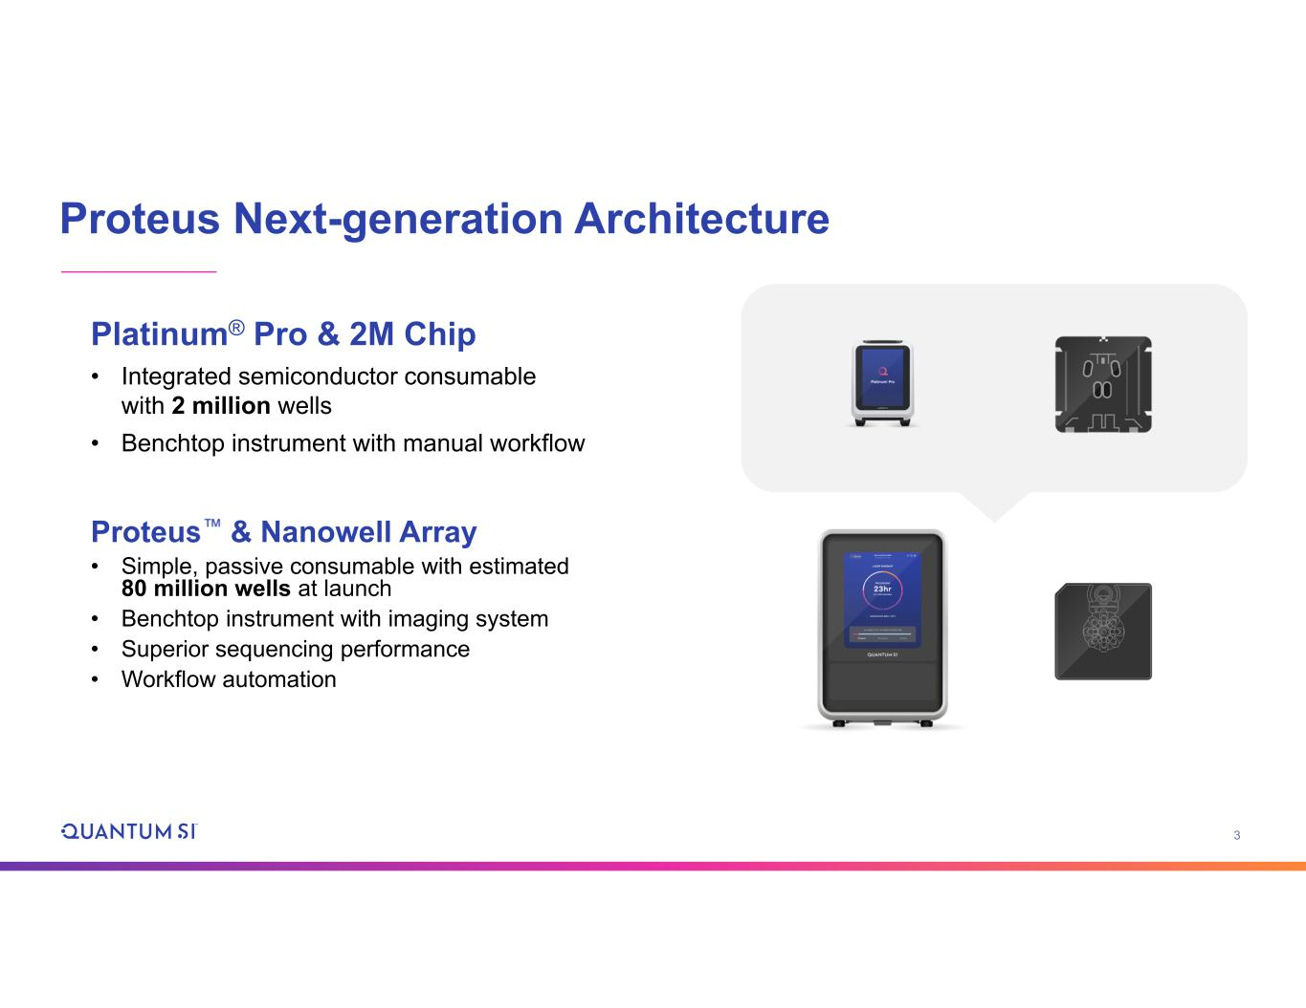
3 Proteus Next-generation Architecture Platinum® Pro & 2M Chip • Integrated semiconductor consumable with 2 million wells • Benchtop instrument with manual workflow Proteus & Nanowell Array • Simple, passive consumable with estimated 80 million wells at launch • Benchtop instrument with imaging system • Superior sequencing performance • Workflow automation

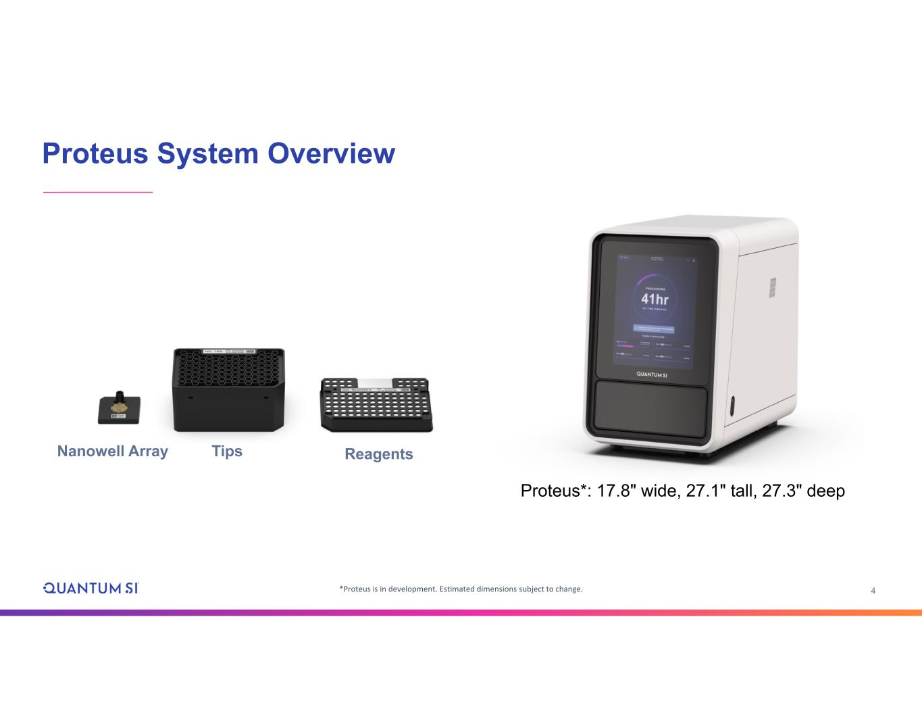
4 Proteus System Overview Nanowell Array Tips Reagents Proteus*: 17.8" wide, 27.1" tall, 27.3" deep *Proteus is in development. Estimated dimensions subject to change.

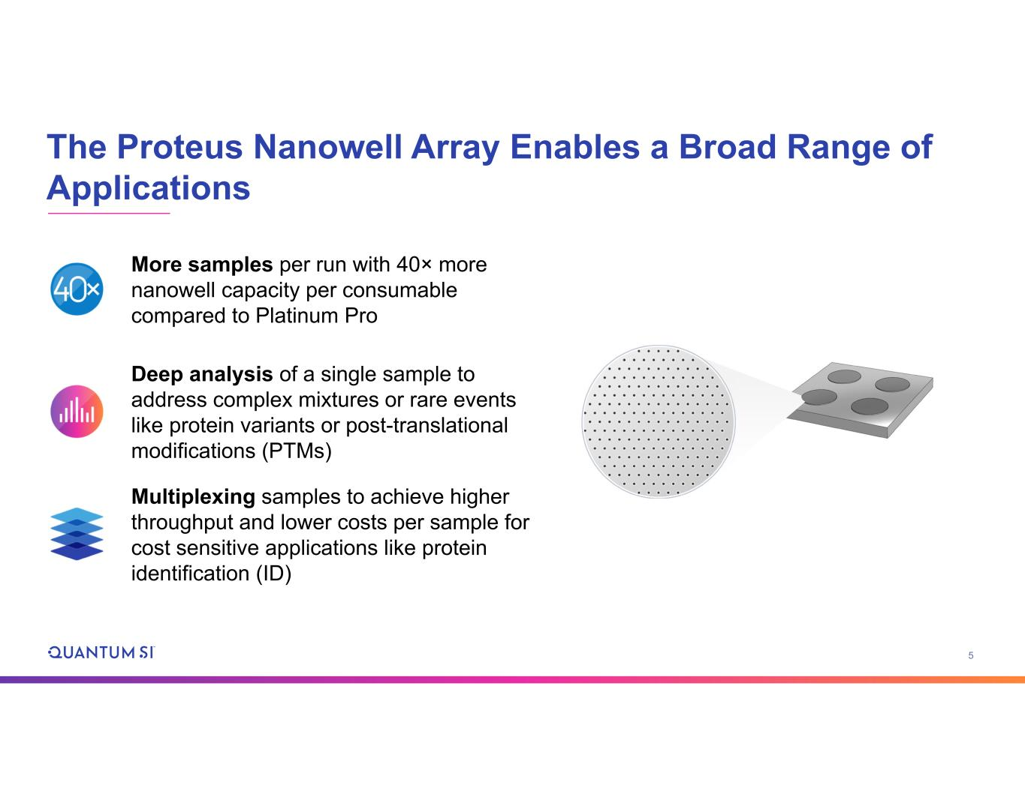
5 The Proteus Nanowell Array Enables a Broad Range of Applications More samples per run with 40× more nanowell capacity per consumable compared to Platinum Pro Deep analysis of a single sample to address complex mixtures or rare events like protein variants or post-translational modifications (PTMs) Multiplexing samples to achieve higher throughput and lower costs per sample for cost sensitive applications like protein identification (ID)

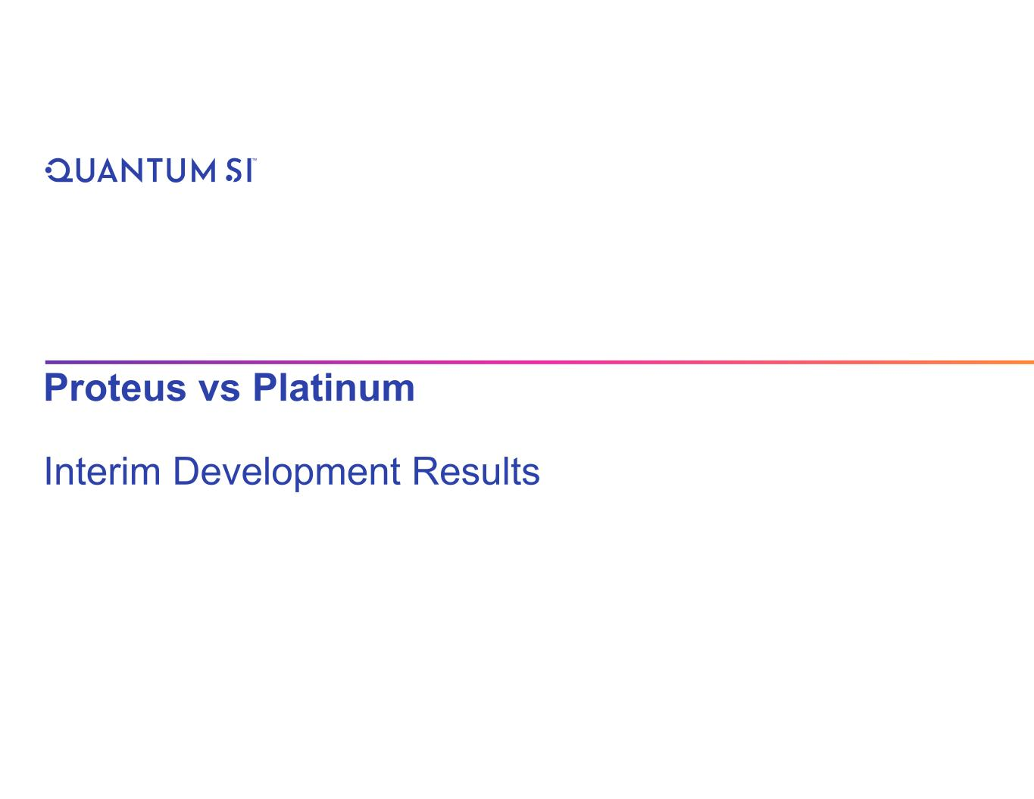
Proteus vs Platinum Interim Development Results

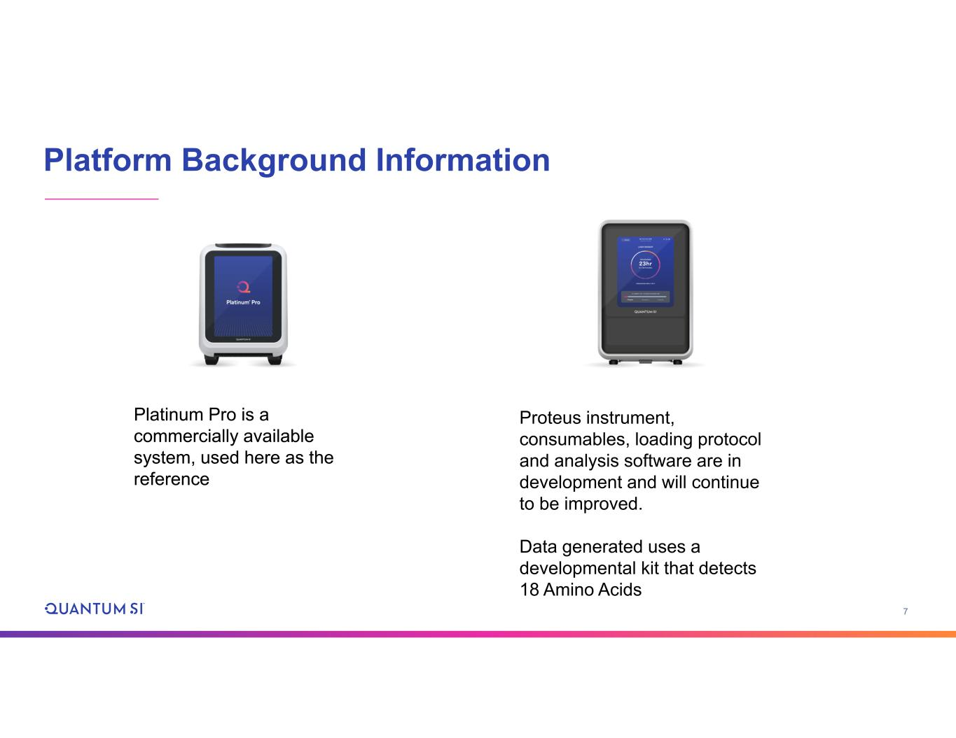
7 Platform Background Information Platinum Pro is a commercially available system, used here as the reference Proteus instrument, consumables, loading protocol and analysis software are in development and will continue to be improved. Data generated uses a developmental kit that detects 18 Amino Acids

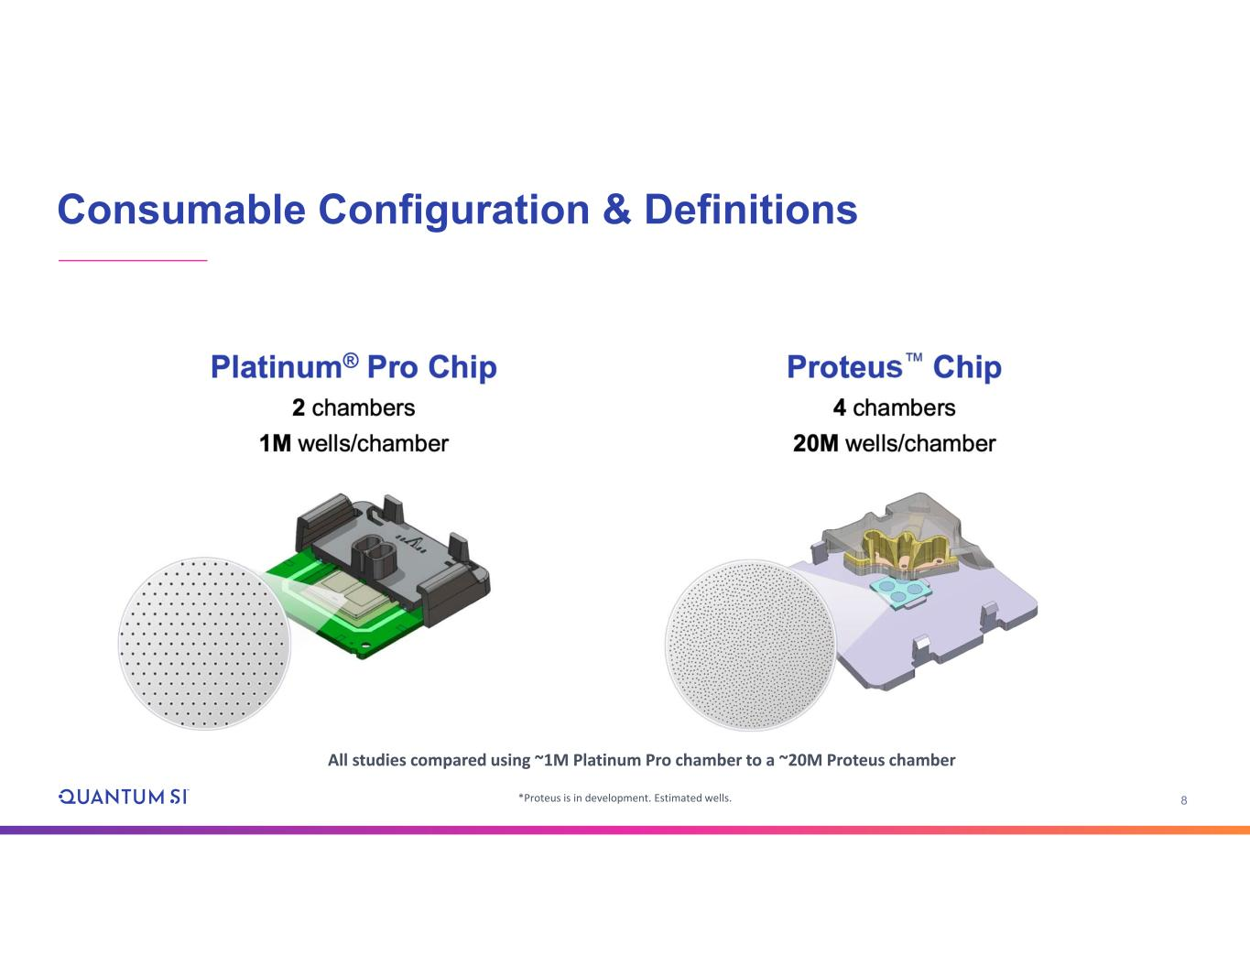
8 Consumable Configuration & Definitions *Proteus is in development. Estimated wells. All studies compared using ~1M Platinum Pro chamber to a ~20M Proteus chamber

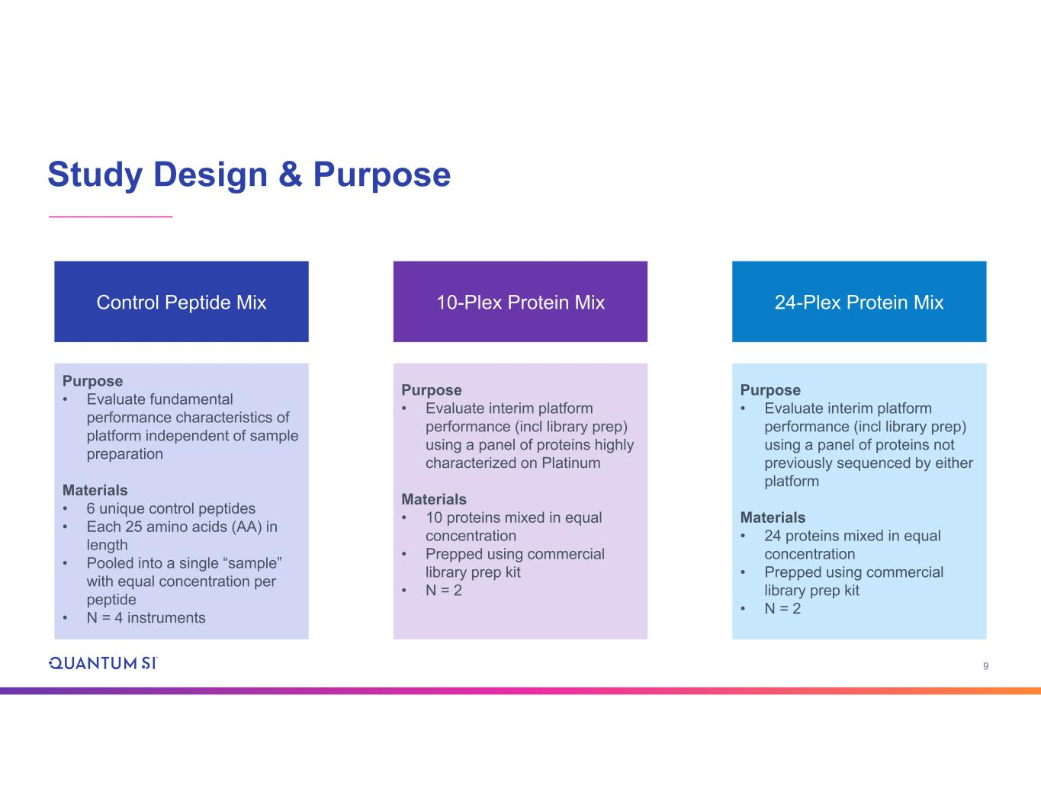
9 Study Design & Purpose Control Peptide Mix Purpose • Evaluate fundamental performance characteristics of platform independent of sample preparation Materials • 6 unique control peptides • Each 25 amino acids (AA) in length • Pooled into a single “sample” with equal concentration per peptide • N = 4 instruments 10-Plex Protein Mix Purpose • Evaluate interim platform performance (incl library prep) using a panel of proteins highly characterized on Platinum Materials • 10 proteins mixed in equal concentration • Prepped using commercial library prep kit • N = 2 24-Plex Protein Mix Purpose • Evaluate interim platform performance (incl library prep) using a panel of proteins not previously sequenced by either platform Materials • 24 proteins mixed in equal concentration • Prepped using commercial library prep kit • N = 2

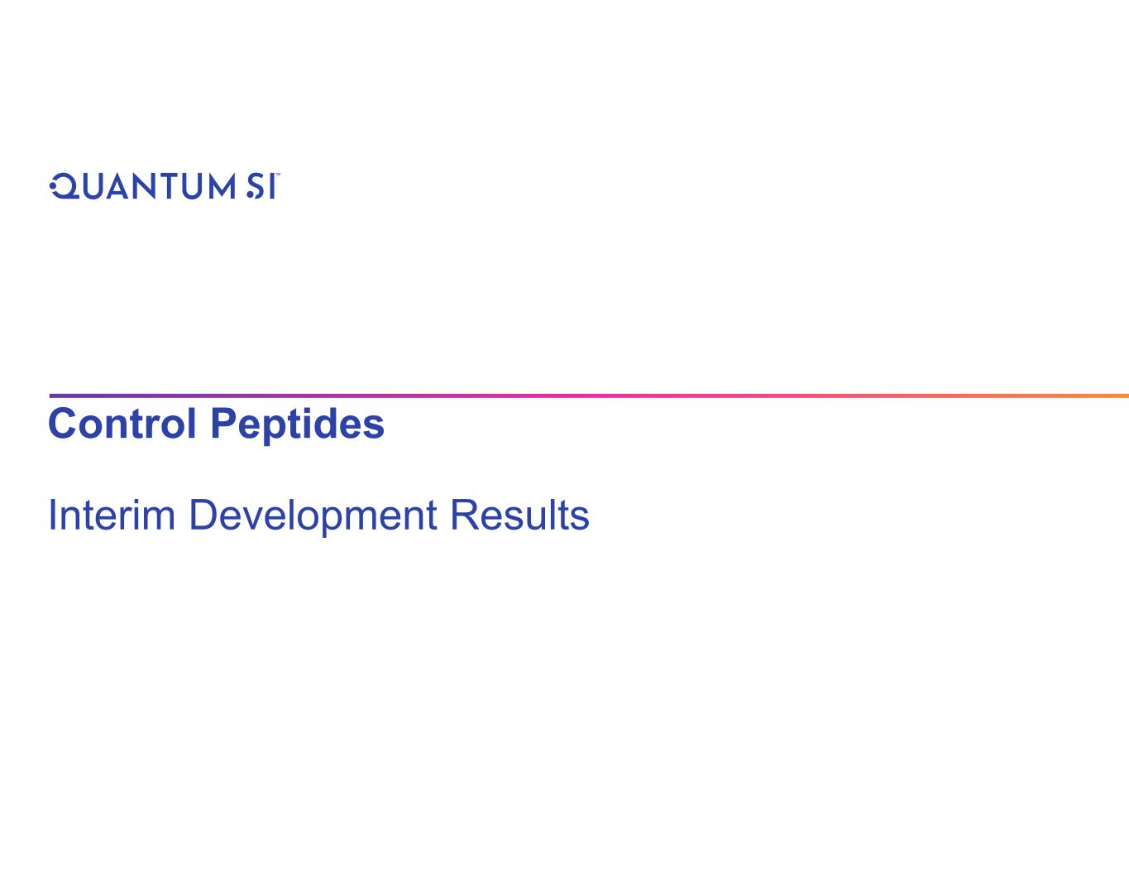
Control Peptides Interim Development Results

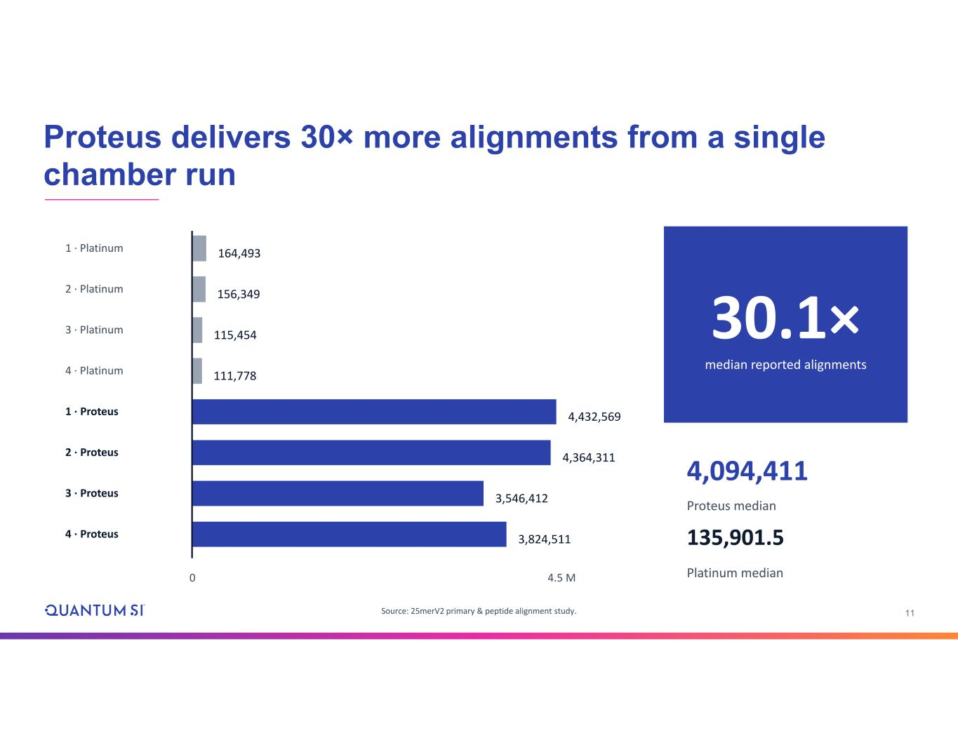
11 1 · Platinum 164,493 2 · Platinum 156,349 3 · Platinum 115,454 4 · Platinum 111,778 1 · Proteus 4,432,569 2 · Proteus 4,364,311 3 · Proteus 3,546,412 4 · Proteus 3,824,511 0 4.5 M 30.1× median reported alignments 4,094,411 Proteus median 135,901.5 Platinum median Proteus delivers 30× more alignments from a single chamber run Source: 25merV2 primary & peptide alignment study.

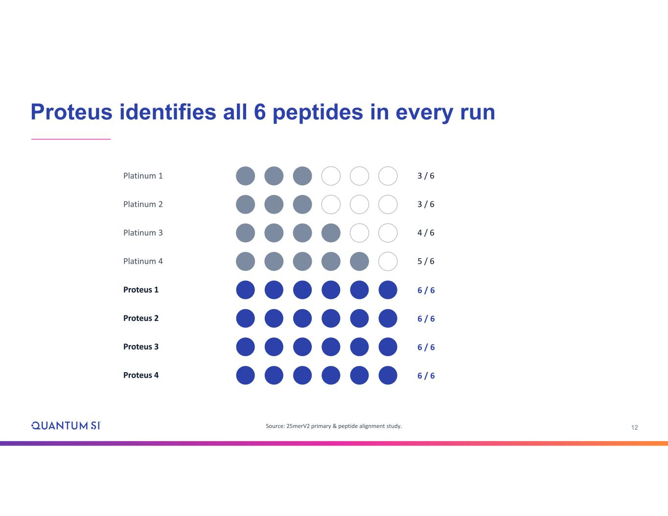
12 Platinum 1 1 3 / 6 Platinum 2 3 / 6 Platinum 3 4 / 6 Platinum 4 5 / 6 Proteus 1 6 / 6 Proteus 2 6 / 6 Proteus 3 6 / 6 Proteus 4 6 / 6 Source: 25merV2 primary & peptide alignment study. Proteus identifies all 6 peptides in every run

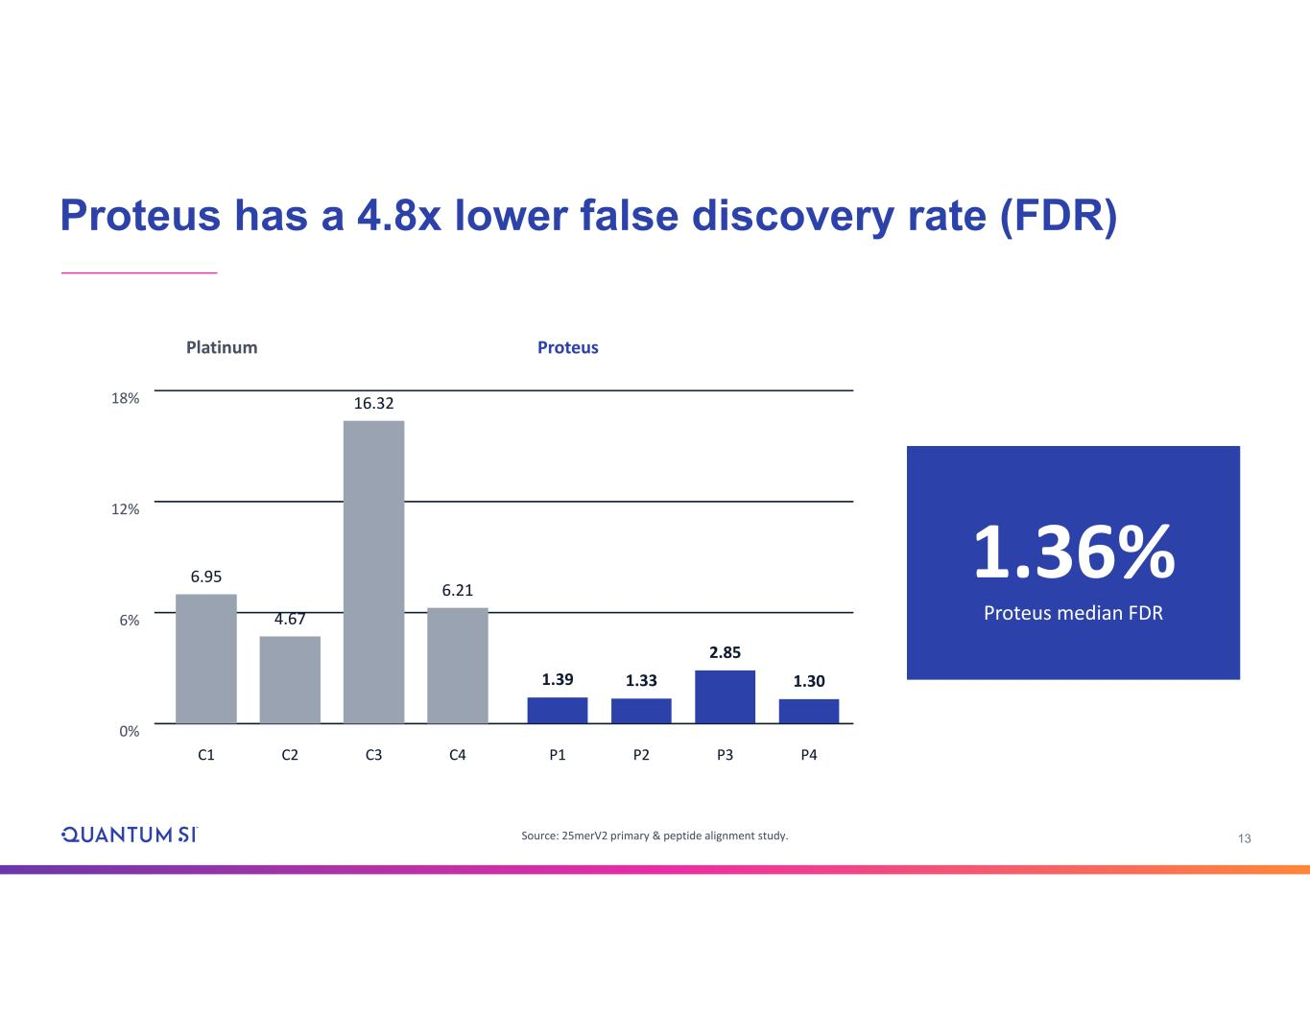
13 0% 6% 12% 18% 6.95 C1 4.67 C2 16.32 C3 6.21 C4 1.39 P1 1.33 P2 2.85 P3 1.30 P4 Platinum Proteus 1.36% Proteus median FDR Proteus has a 4.8x lower false discovery rate (FDR) Source: 25merV2 primary & peptide alignment study.

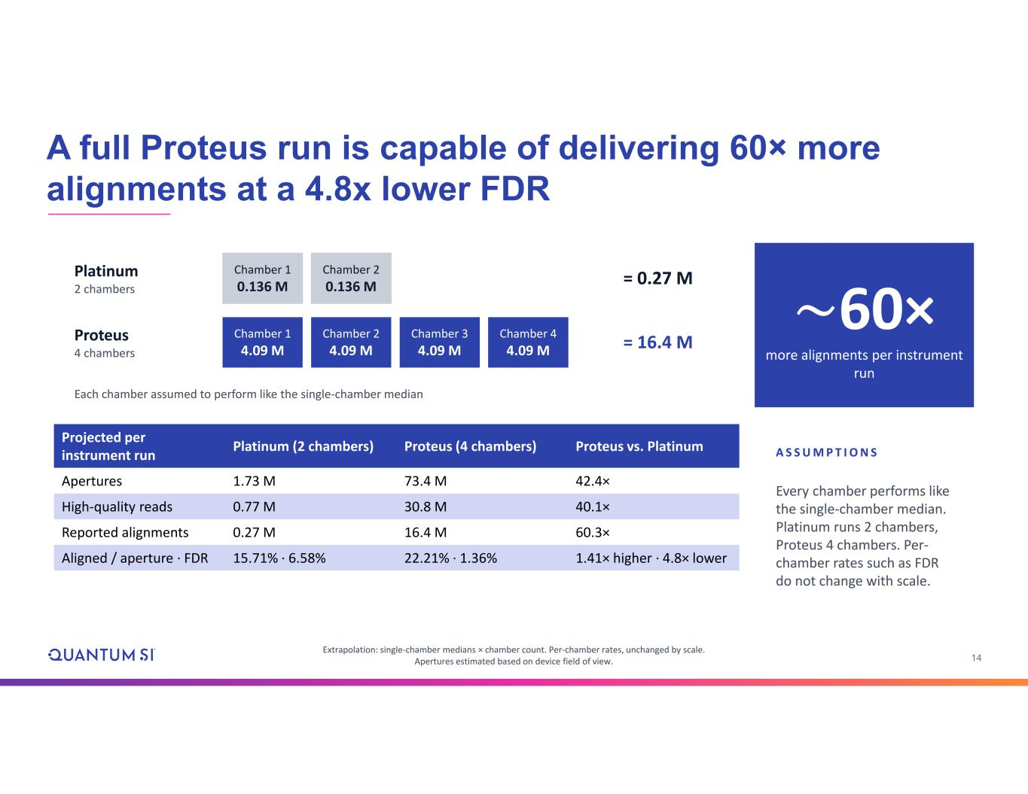
14 Platinum 2 chambers Chamber 1 0.136 M Chamber 2 0.136 M = 0.27 M Proteus 4 chambers Chamber 1 4.09 M Chamber 2 4.09 M Chamber 3 4.09 M Chamber 4 4.09 M = 16.4 M Each chamber assumed to perform like the single-chamber median ~60× more alignments per instrument run Proteus vs. PlatinumProteus (4 chambers)Platinum (2 chambers)Projected per instrument run 42.4×73.4 M1.73 MApertures 40.1×30.8 M0.77 MHigh-quality reads 60.3×16.4 M0.27 MReported alignments 1.41× higher · 4.8× lower22.21% · 1.36%15.71% · 6.58%Aligned / aperture · FDR Extrapolation: single-chamber medians × chamber count. Per-chamber rates, unchanged by scale. Apertures estimated based on device field of view. A S S U M P T I O N S Every chamber performs like the single-chamber median. Platinum runs 2 chambers, Proteus 4 chambers. Per- chamber rates such as FDR do not change with scale. A full Proteus run is capable of delivering 60× more alignments at a 4.8x lower FDR

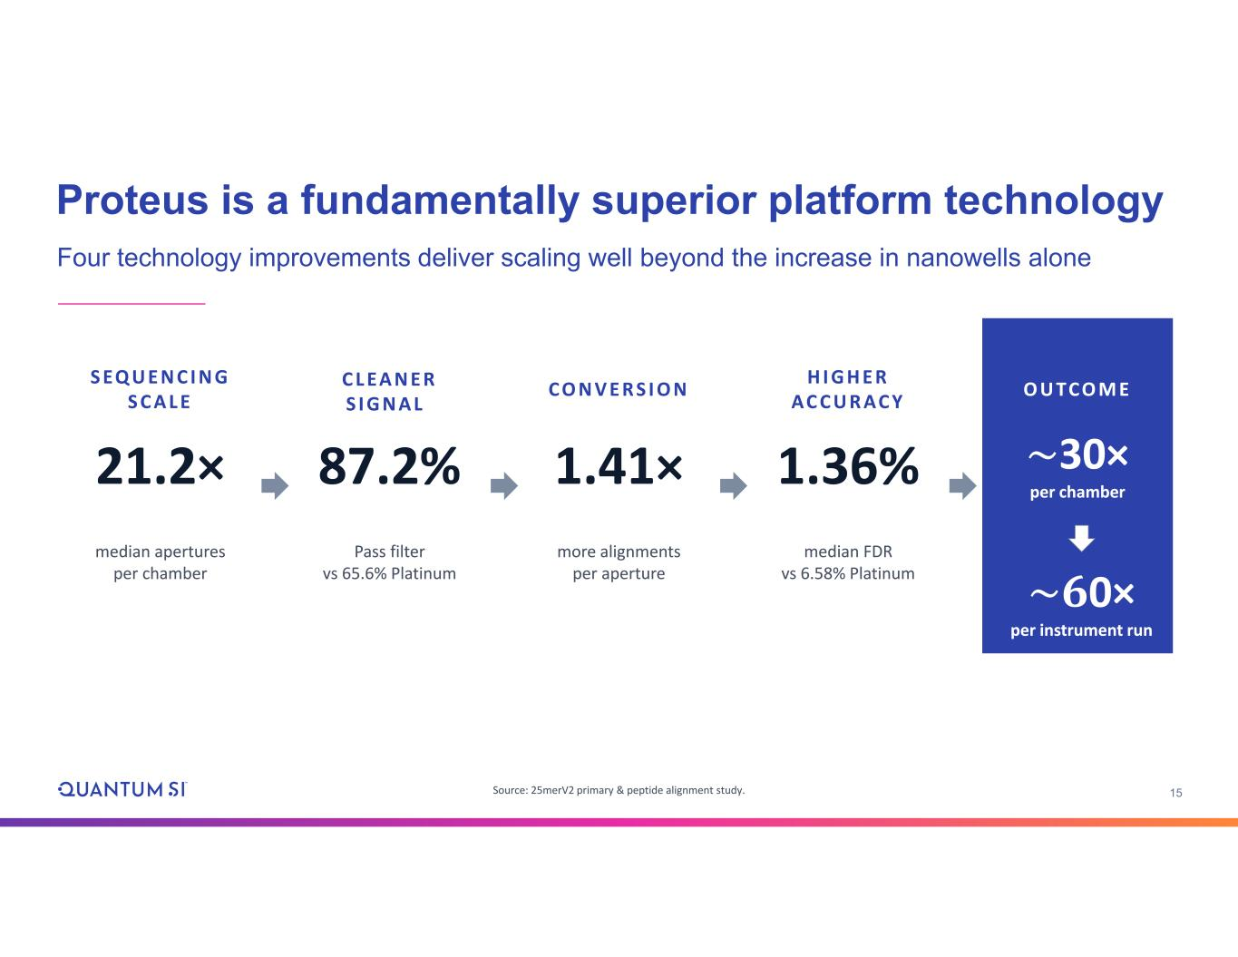
15 S EQ U E N C I N G S C A L E 21.2× median apertures per chamber C L EA N E R S I G N A L 87.2% Pass filter vs 65.6% Platinum C O N V E R S I O N 1.41× more alignments per aperture H I G H E R AC C U R AC Y 1.36% median FDR vs 6.58% Platinum O U TC O M E ~30× per chamber Source: 25merV2 primary & peptide alignment study. Proteus is a fundamentally superior platform technology Four technology improvements deliver scaling well beyond the increase in nanowells alone ~𝟔0× per instrument run

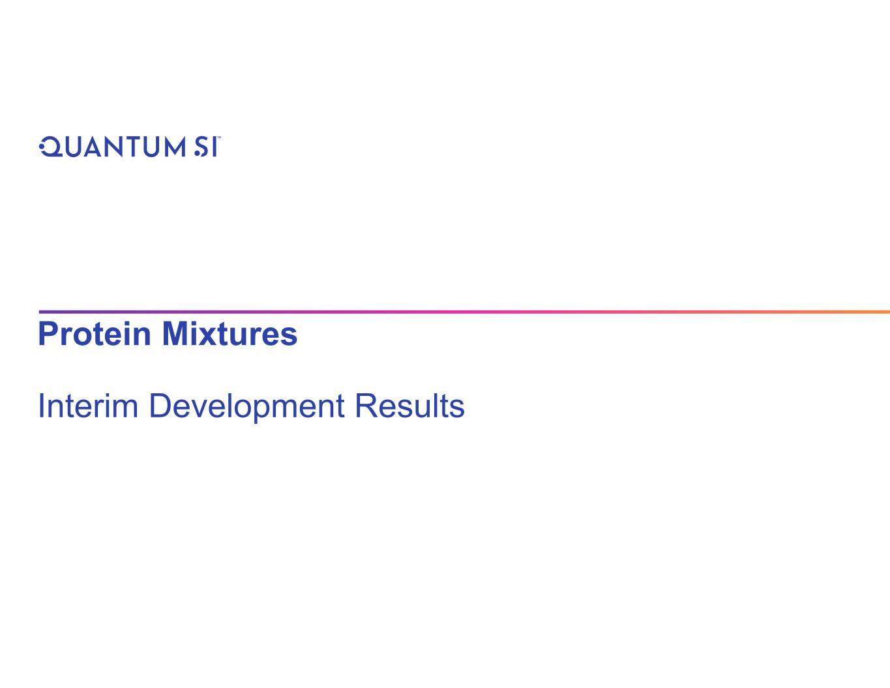
Protein Mixtures Interim Development Results

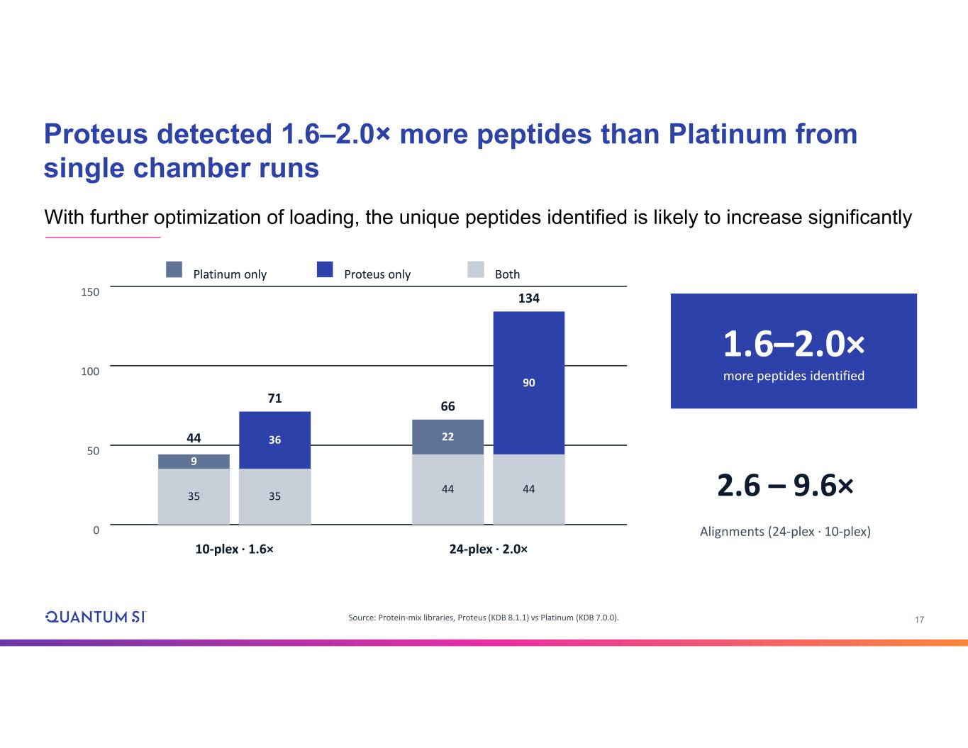
17 Proteus detected 1.6–2.0× more peptides than Platinum from single chamber runs Source: Protein-mix libraries, Proteus (KDB 8.1.1) vs Platinum (KDB 7.0.0). 0 50 100 150 35 9 44 35 36 71 10-plex · 1.6× 44 22 66 44 90 134 24-plex · 2.0× Platinum only Proteus only Both 1.6–2.0× more peptides identified 2.6 – 9.6× Alignments (24-plex · 10-plex) With further optimization of loading, the unique peptides identified is likely to increase significantly

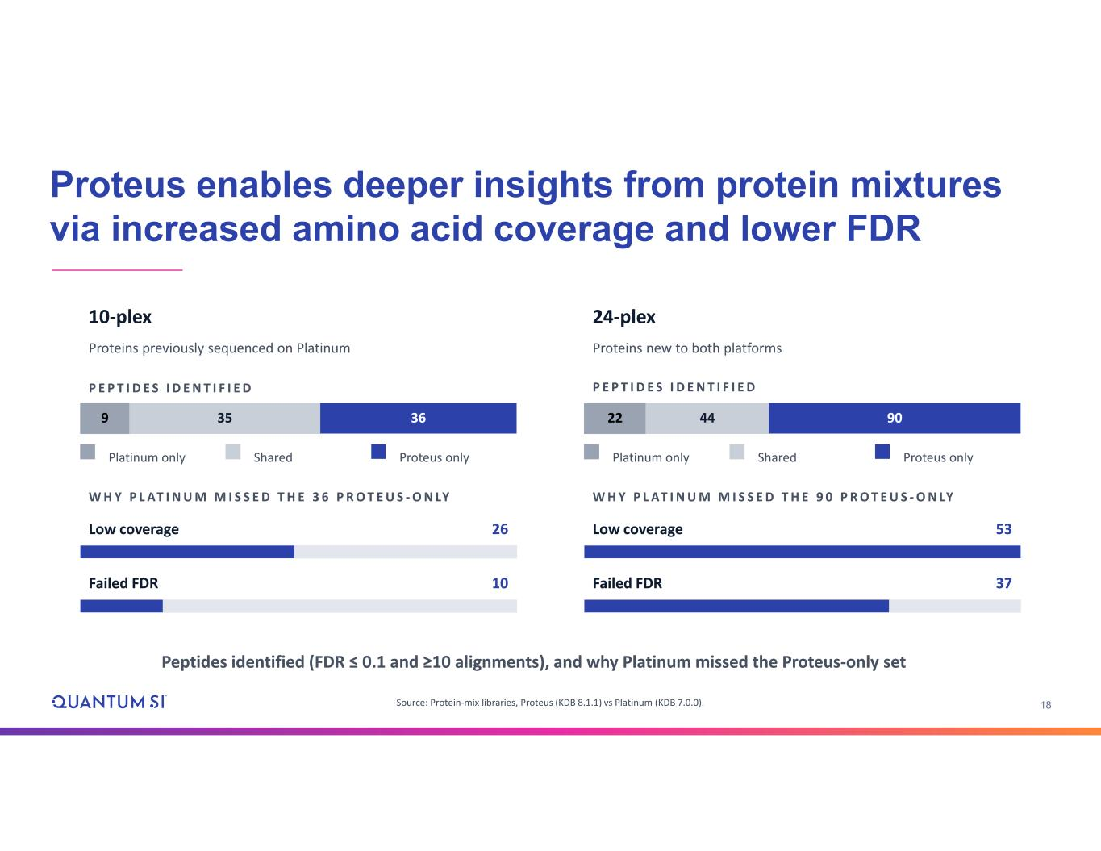
18 Peptides identified (FDR ≤ 0.1 and ≥10 alignments), and why Platinum missed the Proteus-only set 10-plex Proteins previously sequenced on Platinum P E P T I D E S I D E N T I F I E D 9 35 36 Platinum only Shared Proteus only W H Y P L AT I N U M M I S S E D T H E 3 6 P R O T E U S - O N LY Low coverage 26 Failed FDR 10 24-plex Proteins new to both platforms P E P T I D E S I D E N T I F I E D 22 44 90 Platinum only Shared Proteus only W H Y P L AT I N U M M I S S E D T H E 9 0 P R O T E U S - O N LY Low coverage 53 Failed FDR 37 Proteus enables deeper insights from protein mixtures via increased amino acid coverage and lower FDR Source: Protein-mix libraries, Proteus (KDB 8.1.1) vs Platinum (KDB 7.0.0).

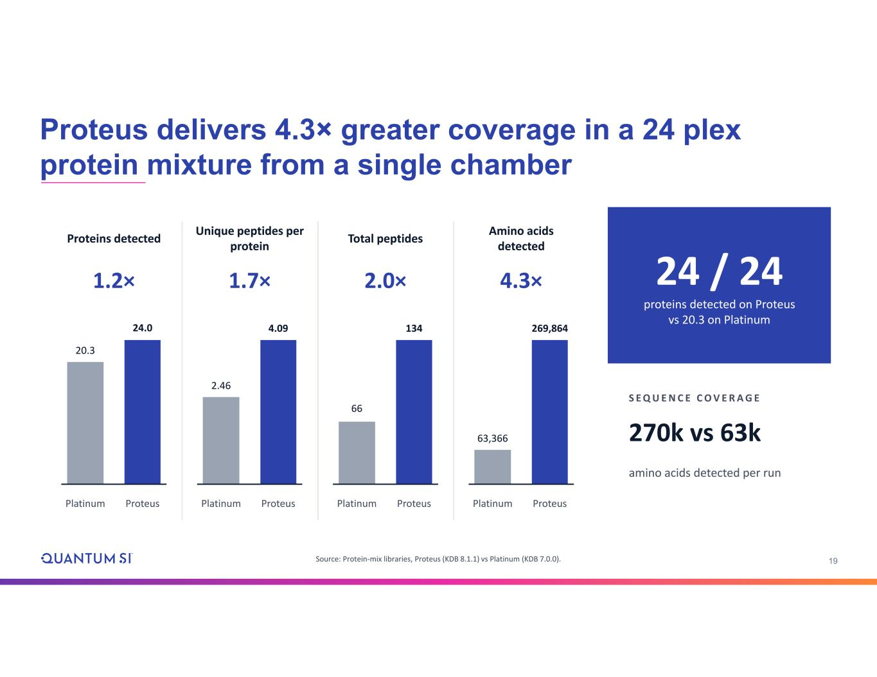
19 Proteins detected 1.2× 20.3 Platinum 24.0 Proteus Unique peptides per protein 1.7× 2.46 Platinum 4.09 Proteus Total peptides 2.0× 66 Platinum 134 Proteus Amino acids detected 4.3× 63,366 Platinum 269,864 Proteus 24 / 24 proteins detected on Proteus vs 20.3 on Platinum S E Q U E N C E C O V E R A G E 270k vs 63k amino acids detected per run Proteus delivers 4.3× greater coverage in a 24 plex protein mixture from a single chamber Source: Protein-mix libraries, Proteus (KDB 8.1.1) vs Platinum (KDB 7.0.0).

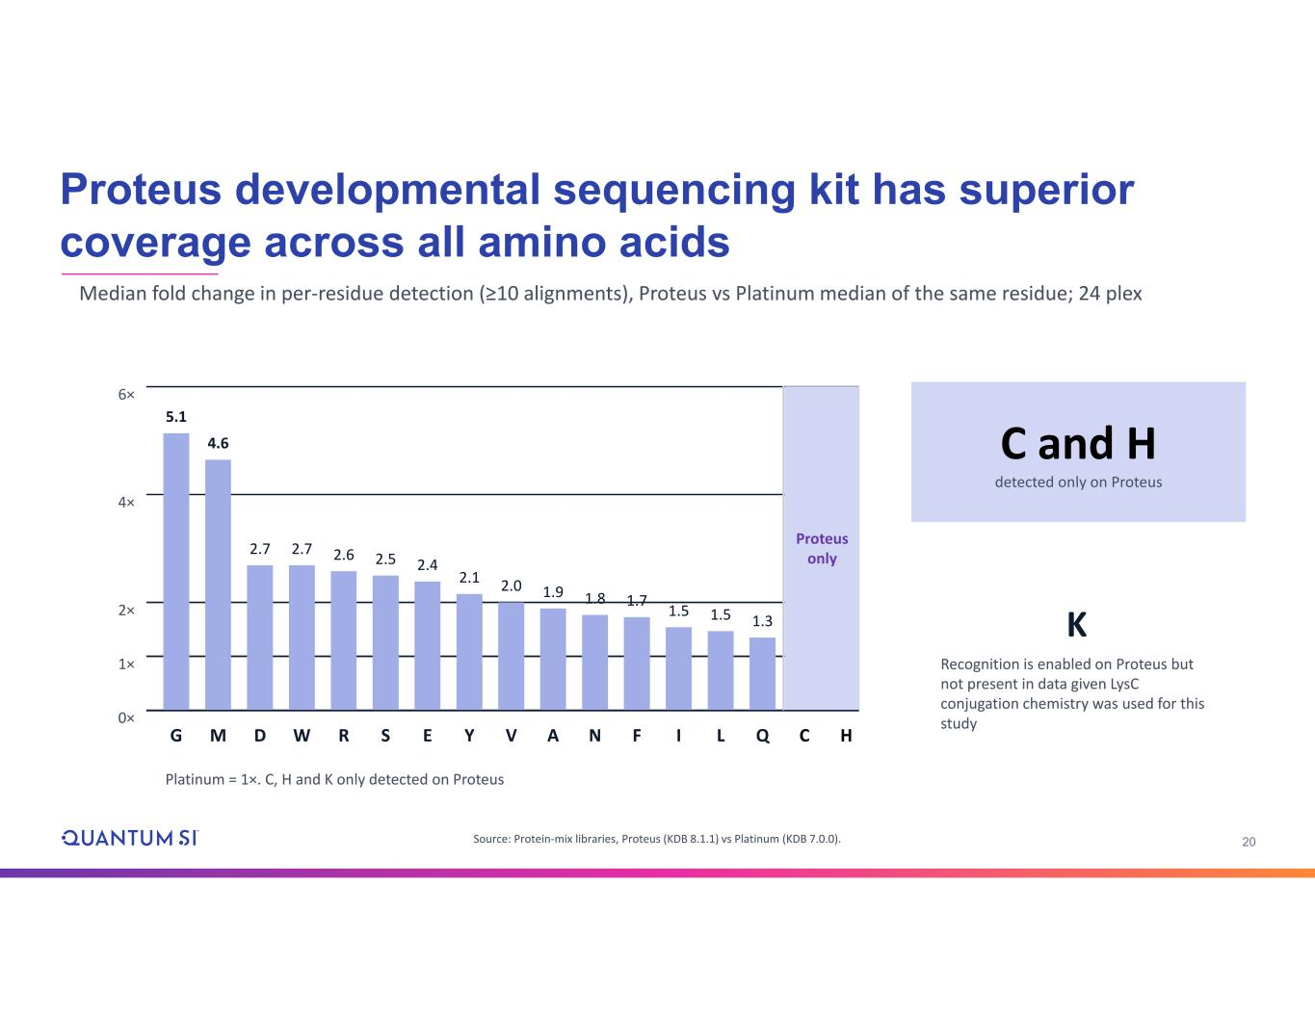
20 Median fold change in per-residue detection (≥10 alignments), Proteus vs Platinum median of the same residue; 24 plex C and H detected only on Proteus K Recognition is enabled on Proteus but not present in data given LysC conjugation chemistry was used for this study Proteus developmental sequencing kit has superior coverage across all amino acids Source: Protein-mix libraries, Proteus (KDB 8.1.1) vs Platinum (KDB 7.0.0). 0× 1× 2× 4× 6× 5.1 G 4.6 M 2.7 D 2.7 W 2.6 R 2.5 S 2.4 E 2.1 Y 2.0 V 1.9 A 1.8 N 1.7 F 1.5 I 1.5 L 1.3 Q Platinum = 1×. C, H and K only detected on Proteus C H Proteus only

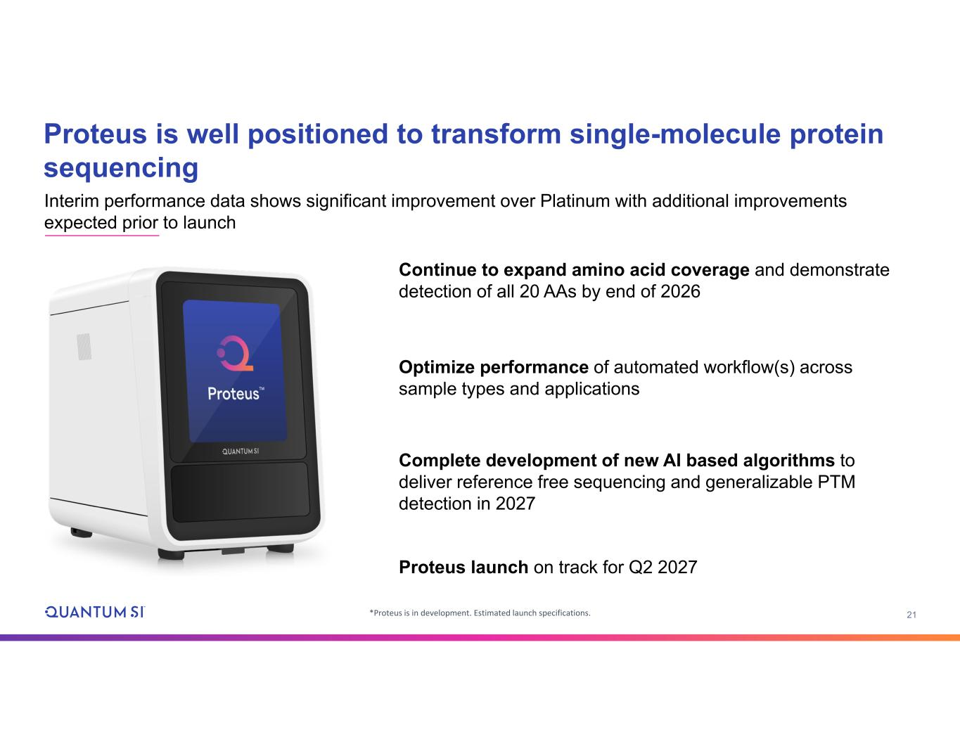
21*Proteus is in development. Estimated launch specifications. Continue to expand amino acid coverage and demonstrate detection of all 20 AAs by end of 2026 Optimize performance of automated workflow(s) across sample types and applications Complete development of new AI based algorithms to deliver reference free sequencing and generalizable PTM detection in 2027 Proteus launch on track for Q2 2027 Proteus is well positioned to transform single-molecule protein sequencing Interim performance data shows significant improvement over Platinum with additional improvements expected prior to launch

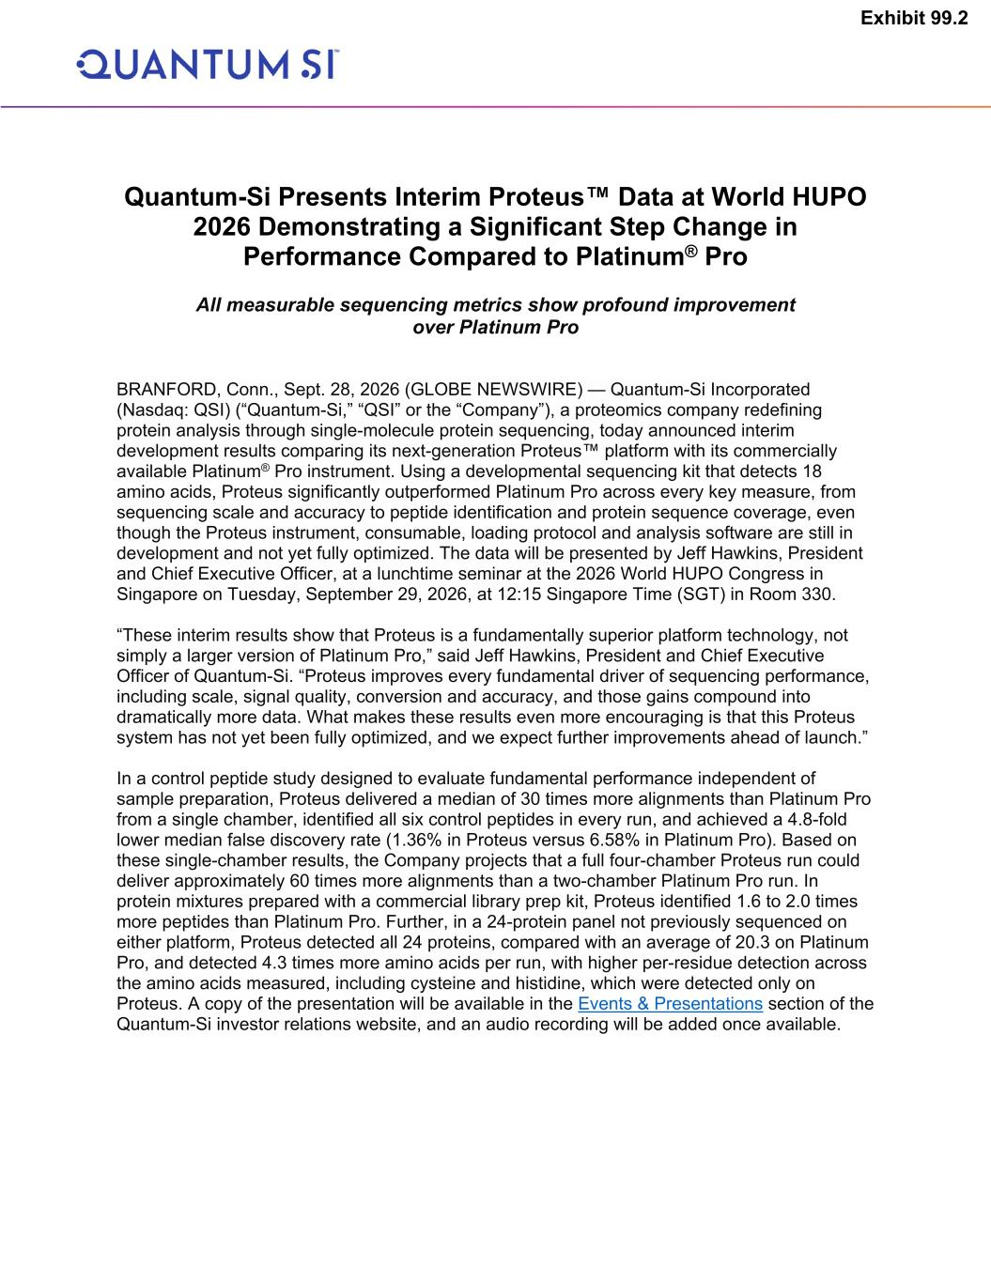
Quantum-Si Presents Interim Proteus™ Data at World HUPO 2026 Demonstrating a Significant Step Change in Performance Compared to Platinum® Pro All measurable sequencing metrics show profound improvement over Platinum Pro BRANFORD, Conn., Sept. 28, 2026 (GLOBE NEWSWIRE) — Quantum-Si Incorporated (Nasdaq: QSI) (“Quantum-Si,” “QSI” or the “Company”), a proteomics company redefining protein analysis through single-molecule protein sequencing, today announced interim development results comparing its next-generation Proteus™ platform with its commercially available Platinum® Pro instrument. Using a developmental sequencing kit that detects 18 amino acids, Proteus significantly outperformed Platinum Pro across every key measure, from sequencing scale and accuracy to peptide identification and protein sequence coverage, even though the Proteus instrument, consumable, loading protocol and analysis software are still in development and not yet fully optimized. The data will be presented by Jeff Hawkins, President and Chief Executive Officer, at a lunchtime seminar at the 2026 World HUPO Congress in Singapore on Tuesday, September 29, 2026, at 12:15 Singapore Time (SGT) in Room 330. “These interim results show that Proteus is a fundamentally superior platform technology, not simply a larger version of Platinum Pro,” said Jeff Hawkins, President and Chief Executive Officer of Quantum-Si. “Proteus improves every fundamental driver of sequencing performance, including scale, signal quality, conversion and accuracy, and those gains compound into dramatically more data. What makes these results even more encouraging is that this Proteus system has not yet been fully optimized, and we expect further improvements ahead of launch.” In a control peptide study designed to evaluate fundamental performance independent of sample preparation, Proteus delivered a median of 30 times more alignments than Platinum Pro from a single chamber, identified all six control peptides in every run, and achieved a 4.8-fold lower median false discovery rate (1.36% in Proteus versus 6.58% in Platinum Pro). Based on these single-chamber results, the Company projects that a full four-chamber Proteus run could deliver approximately 60 times more alignments than a two-chamber Platinum Pro run. In protein mixtures prepared with a commercial library prep kit, Proteus identified 1.6 to 2.0 times more peptides than Platinum Pro. Further, in a 24-protein panel not previously sequenced on either platform, Proteus detected all 24 proteins, compared with an average of 20.3 on Platinum Pro, and detected 4.3 times more amino acids per run, with higher per-residue detection across the amino acids measured, including cysteine and histidine, which were detected only on Proteus. A copy of the presentation will be available in the Events & Presentations section of the Quantum-Si investor relations website, and an audio recording will be added once available. Exhibit 99.2

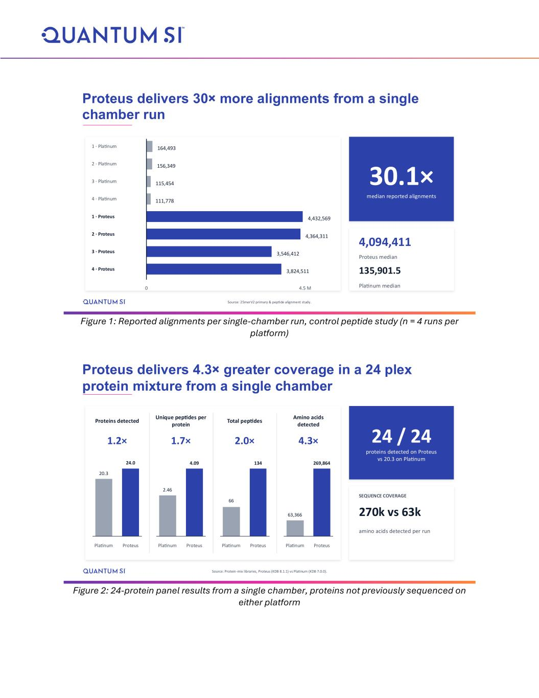
Figure 1: Reported alignments per single-chamber run, control peptide study (n = 4 runs per platform) Figure 2: 24-protein panel results from a single chamber, proteins not previously sequenced on either platform 1 · Platinum 164,493 2 · Platinum 156,349 3 · Platinum 115,454 4 · Platinum 111,778 1 · Proteus 4,432,569 2 · Proteus 4,364,311 3 · Proteus 3,546,412 4 · Proteus 3,824,511 0 4.5 M 30.1× median reported alignments 4,094,411 Proteus median 135,901.5 Platinum median Proteus delivers 30× more alignments from a single chamber run Source: 25merV2 primary & peptide alignment study. Proteins detected 1.2× 20.3 Platinum 24.0 Proteus Unique peptides per protein 1.7× 2.46 Platinum 4.09 Proteus Total peptides 2.0× 66 Platinum 134 Proteus Amino acids detected 4.3× 63,366 Platinum 269,864 Proteus 24 / 24 proteins detected on Proteus vs 20.3 on Platinum SEQUENCE COVERAGE 270k vs 63k amino acids detected per run Proteus delivers 4.3× greater coverage in a 24 plex protein mixture from a single chamber Source: Protein-mix libraries, Proteus (KDB 8.1.1) vs Platinum (KDB 7.0.0).

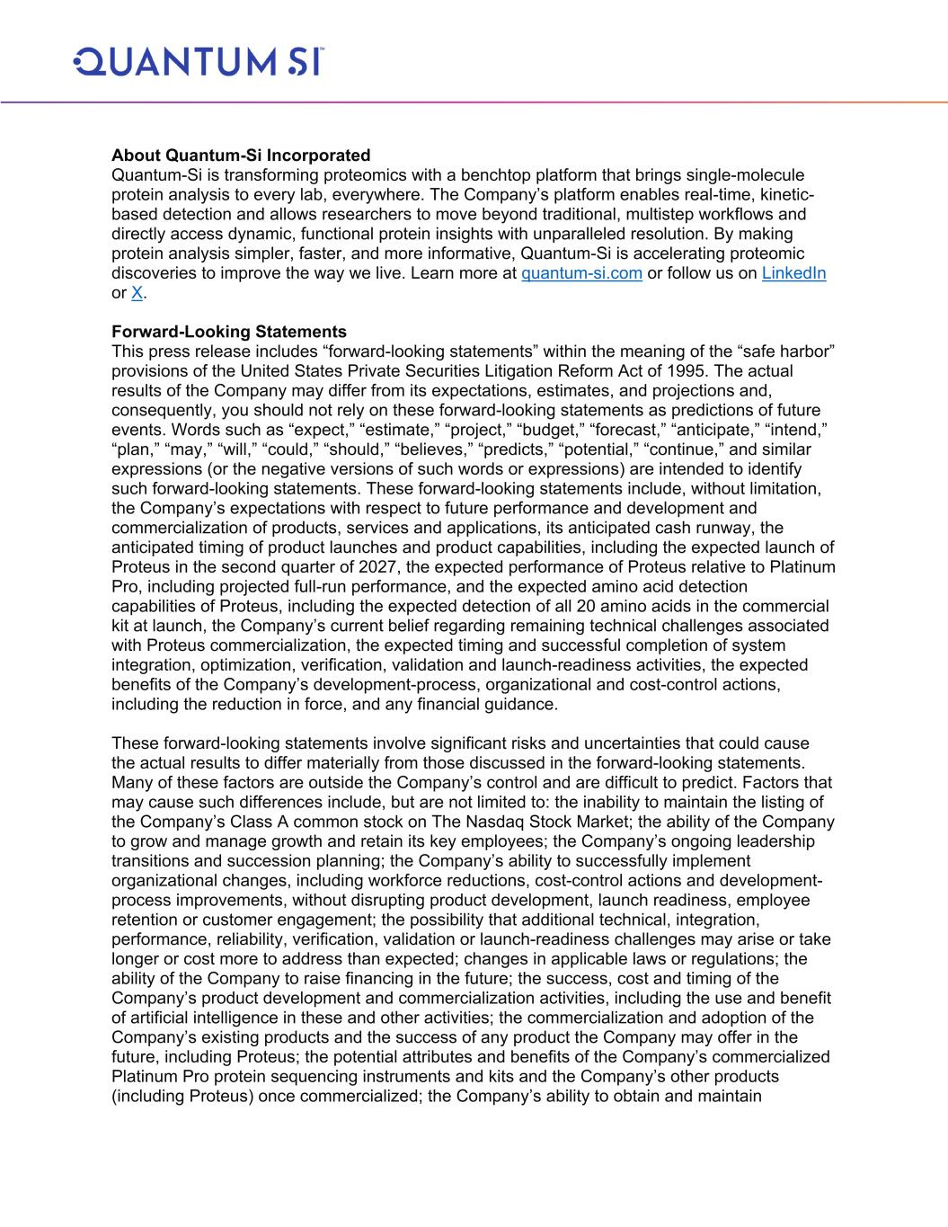
About Quantum-Si Incorporated Quantum-Si is transforming proteomics with a benchtop platform that brings single-molecule protein analysis to every lab, everywhere. The Company’s platform enables real-time, kinetic- based detection and allows researchers to move beyond traditional, multistep workflows and directly access dynamic, functional protein insights with unparalleled resolution. By making protein analysis simpler, faster, and more informative, Quantum-Si is accelerating proteomic discoveries to improve the way we live. Learn more at quantum-si.com or follow us on LinkedIn or X. Forward-Looking Statements This press release includes “forward-looking statements” within the meaning of the “safe harbor” provisions of the United States Private Securities Litigation Reform Act of 1995. The actual results of the Company may differ from its expectations, estimates, and projections and, consequently, you should not rely on these forward-looking statements as predictions of future events. Words such as “expect,” “estimate,” “project,” “budget,” “forecast,” “anticipate,” “intend,” “plan,” “may,” “will,” “could,” “should,” “believes,” “predicts,” “potential,” “continue,” and similar expressions (or the negative versions of such words or expressions) are intended to identify such forward-looking statements. These forward-looking statements include, without limitation, the Company’s expectations with respect to future performance and development and commercialization of products, services and applications, its anticipated cash runway, the anticipated timing of product launches and product capabilities, including the expected launch of Proteus in the second quarter of 2027, the expected performance of Proteus relative to Platinum Pro, including projected full-run performance, and the expected amino acid detection capabilities of Proteus, including the expected detection of all 20 amino acids in the commercial kit at launch, the Company’s current belief regarding remaining technical challenges associated with Proteus commercialization, the expected timing and successful completion of system integration, optimization, verification, validation and launch-readiness activities, the expected benefits of the Company’s development-process, organizational and cost-control actions, including the reduction in force, and any financial guidance. These forward-looking statements involve significant risks and uncertainties that could cause the actual results to differ materially from those discussed in the forward-looking statements. Many of these factors are outside the Company’s control and are difficult to predict. Factors that may cause such differences include, but are not limited to: the inability to maintain the listing of the Company’s Class A common stock on The Nasdaq Stock Market; the ability of the Company to grow and manage growth and retain its key employees; the Company’s ongoing leadership transitions and succession planning; the Company’s ability to successfully implement organizational changes, including workforce reductions, cost-control actions and development- process improvements, without disrupting product development, launch readiness, employee retention or customer engagement; the possibility that additional technical, integration, performance, reliability, verification, validation or launch-readiness challenges may arise or take longer or cost more to address than expected; changes in applicable laws or regulations; the ability of the Company to raise financing in the future; the success, cost and timing of the Company’s product development and commercialization activities, including the use and benefit of artificial intelligence in these and other activities; the commercialization and adoption of the Company’s existing products and the success of any product the Company may offer in the future, including Proteus; the potential attributes and benefits of the Company’s commercialized Platinum Pro protein sequencing instruments and kits and the Company’s other products (including Proteus) once commercialized; the Company’s ability to obtain and maintain

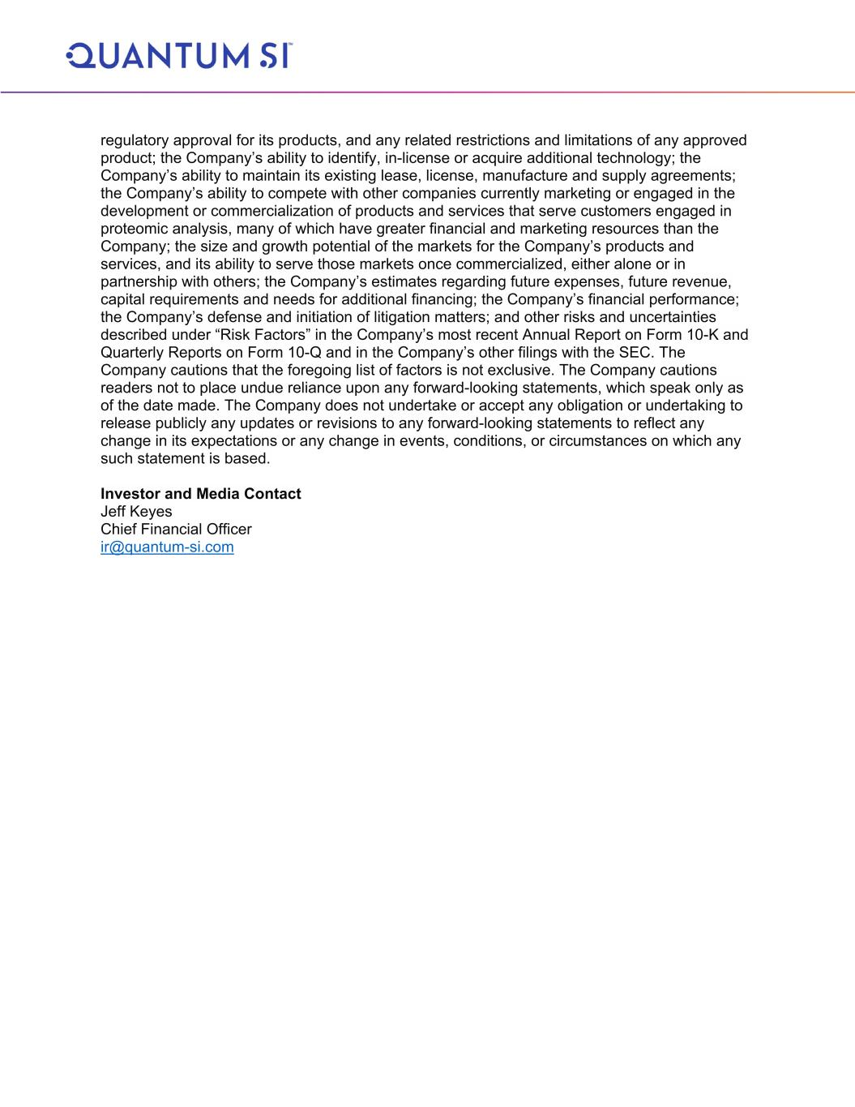
regulatory approval for its products, and any related restrictions and limitations of any approved product; the Company’s ability to identify, in-license or acquire additional technology; the Company’s ability to maintain its existing lease, license, manufacture and supply agreements; the Company’s ability to compete with other companies currently marketing or engaged in the development or commercialization of products and services that serve customers engaged in proteomic analysis, many of which have greater financial and marketing resources than the Company; the size and growth potential of the markets for the Company’s products and services, and its ability to serve those markets once commercialized, either alone or in partnership with others; the Company’s estimates regarding future expenses, future revenue, capital requirements and needs for additional financing; the Company’s financial performance; the Company’s defense and initiation of litigation matters; and other risks and uncertainties described under “Risk Factors” in the Company’s most recent Annual Report on Form 10-K and Quarterly Reports on Form 10-Q and in the Company’s other filings with the SEC. The Company cautions that the foregoing list of factors is not exclusive. The Company cautions readers not to place undue reliance upon any forward-looking statements, which speak only as of the date made. The Company does not undertake or accept any obligation or undertaking to release publicly any updates or revisions to any forward-looking statements to reflect any change in its expectations or any change in events, conditions, or circumstances on which any such statement is based. Investor and Media Contact Jeff Keyes Chief Financial Officer ir@quantum-si.com

