UNITED STATES
SECURITIES AND EXCHANGE COMMISSION
Washington, D.C. 20549
FORM 8-K
CURRENT REPORT
Pursuant to Section 13 OR 15(d) of the
Securities Exchange Act of 1934
Date of Report (Date of earliest event reported): October 8, 2026
QUANTUM-SI INCORPORATED
(Exact name of registrant as specified in its charter)

Delaware |  |  | 001-39486 |  |  | 85-1388175
(State or other jurisdiction of incorporation) |  |  | (Commission File Number) |  |  | (IRS Employer Identification No.)
29 Business Park Drive
Branford, Connecticut |  |  |  |  |  | 06405
(Address of principal executive offices) |  |  |  |  |  | (Zip Code)
Registrant’s telephone number, including area code: (866) 688-7374
N/A
(Former name or former address, if changed since last report)

Check the appropriate box below if the Form 8-K filing is intended to simultaneously satisfy the filing obligation of the registrant under any of the following provisions:
o |  |  | Written communications pursuant to Rule 425 under the Securities Act (17 CFR 230.425)
o |  |  | Soliciting material pursuant to Rule 14a-12 under the Exchange Act (17 CFR 240.14a-12)
o |  |  | Pre-commencement communications pursuant to Rule 14d-2(b) under the Exchange Act (17 CFR 240.14d-2(b))
o |  |  | Pre-commencement communications pursuant to Rule 13e-4(c) under the Exchange Act (17 CFR 240.13e-4(c))
Securities registered pursuant to Section 12(b) of the Act:
Title of each class |  |  |  |  |  | Trading Symbol(s) |  |  |  |  |  | Name of each exchange on  which registered
Class A common stock, par value $0.0001 per share |  |  |  |  |  | QSI |  |  |  |  |  | The Nasdaq Stock Market LLC
Indicate by check mark whether the registrant is an emerging growth company as defined in Rule 405 of the Securities Act of 1933 (§230.405 of this chapter) or Rule 12b-2 of the Securities Exchange Act of 1934 (§240.12b-2 of this chapter).
Emerging growth company o
If an emerging growth company, indicate by check mark if the registrant has elected not to use the extended transition period for complying with any new or revised financial accounting standards provided pursuant to Section 13(a) of the Exchange Act. o

Item 7.01 Regulation FD Disclosure.

From time to time, Quantum-Si Incorporated (the “Company”) distributes press releases to the investment community to provide updates and summaries of its business. On October 8, 2026, the Company issued a press release announcing that it has demonstrated detection of 19 amino acids in its Proteus™ development program. This press release is also furnished as Exhibit 99.1 to this Current Report on Form 8-K.

The information in this Item 7.01, including Exhibit 99.1, is being furnished and shall not be deemed “filed” for purposes of Section 18 of the Securities Exchange Act of 1934, as amended (the “Exchange Act”), or otherwise subject to the liabilities of that Section, nor shall it be deemed incorporated by reference into any registration statement or other filing under the Securities Act of 1933, as amended, or the Exchange Act, except as shall be expressly set forth by specific reference in such filing. The furnishing of the information in this Item 7.01 and Exhibit 99.1 is not intended to, and does not, constitute a determination or admission by the Company that the information in this report is material or complete, or that investors should consider this information before making an investment decision with respect to any security of the Company or any of its affiliates.

Forward-looking Statements

Certain information discussed in this Current Report on Form 8-K is forward-looking information that involves risks, uncertainties and assumptions. Forward-looking statements may be identified by words such as “anticipate,” “believe,” “condition,” “expect,” “if,” “intend,” “may,” “will,” “planned” and similar expressions. Forward-looking statements involve known and unknown risks and uncertainties that may cause our actual plans or results to differ from our assumptions or expectations. Our risks are more fully described in our filings with the Securities and Exchange Commission, including our most recently filed Annual Report on Form 10-K, as updated in subsequently filed Quarterly Reports on Form 10-Q, as applicable. Forward-looking statements speak only as of the date they are made, and we expressly disclaim any obligation to update any forward-looking information.

Item 9.01 Financial Statements and Exhibits.
(d)Exhibits.
Exhibit  No. |  |  |  |  |  | Description
99.1 |  |  |  |  |  | Press release dated October 8, 2026
104 |  |  |  |  |  | Cover Page Interactive Data File (embedded within the Inline XBRL document)

SIGNATURES
Pursuant to the requirements of the Securities Exchange Act of 1934, the registrant has duly caused this report to be signed on its behalf by the undersigned hereunto duly authorized.
 |  |  | QUANTUM-SI INCORPORATED
 |  |  | By: |  |  | /s/ Jeffry Keyes
 |  |  | Name: |  |  | Jeffry Keyes
 |  |  | Title: |  |  | Chief Financial Officer
Date: October 8, 2026
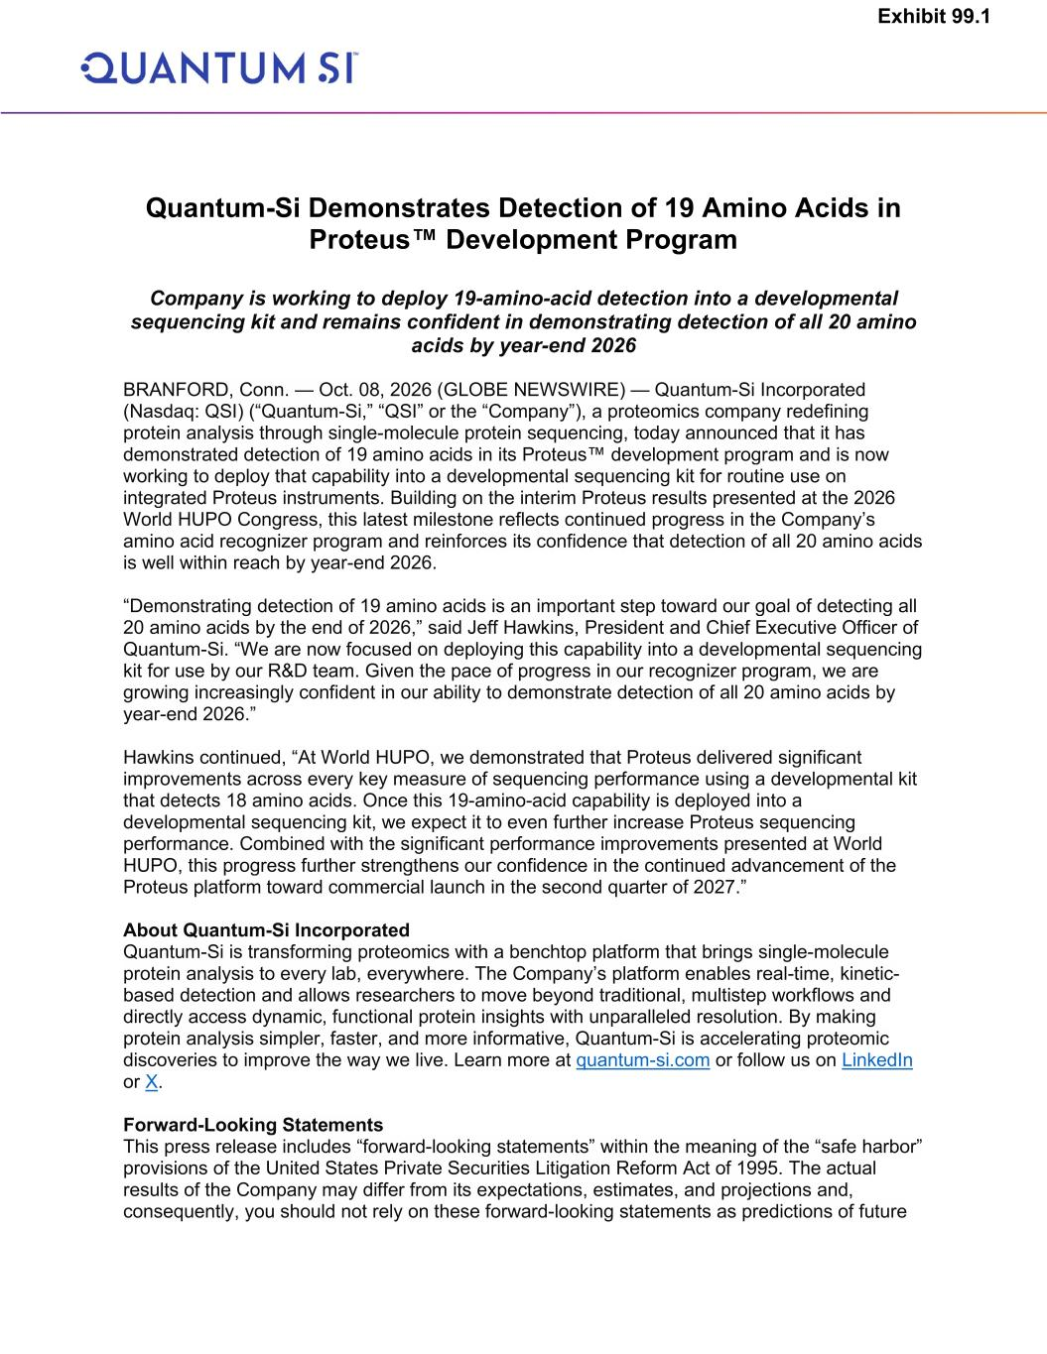

Quantum-Si Demonstrates Detection of 19 Amino Acids in Proteus™ Development Program Company is working to deploy 19-amino-acid detection into a developmental sequencing kit and remains confident in demonstrating detection of all 20 amino acids by year-end 2026 BRANFORD, Conn. — Oct. 08, 2026 (GLOBE NEWSWIRE) — Quantum-Si Incorporated (Nasdaq: QSI) (“Quantum-Si,” “QSI” or the “Company”), a proteomics company redefining protein analysis through single-molecule protein sequencing, today announced that it has demonstrated detection of 19 amino acids in its Proteus™ development program and is now working to deploy that capability into a developmental sequencing kit for routine use on integrated Proteus instruments. Building on the interim Proteus results presented at the 2026 World HUPO Congress, this latest milestone reflects continued progress in the Company’s amino acid recognizer program and reinforces its confidence that detection of all 20 amino acids is well within reach by year-end 2026. “Demonstrating detection of 19 amino acids is an important step toward our goal of detecting all 20 amino acids by the end of 2026,” said Jeff Hawkins, President and Chief Executive Officer of Quantum-Si. “We are now focused on deploying this capability into a developmental sequencing kit for use by our R&D team. Given the pace of progress in our recognizer program, we are growing increasingly confident in our ability to demonstrate detection of all 20 amino acids by year-end 2026.” Hawkins continued, “At World HUPO, we demonstrated that Proteus delivered significant improvements across every key measure of sequencing performance using a developmental kit that detects 18 amino acids. Once this 19-amino-acid capability is deployed into a developmental sequencing kit, we expect it to even further increase Proteus sequencing performance. Combined with the significant performance improvements presented at World HUPO, this progress further strengthens our confidence in the continued advancement of the Proteus platform toward commercial launch in the second quarter of 2027.” About Quantum-Si Incorporated Quantum-Si is transforming proteomics with a benchtop platform that brings single-molecule protein analysis to every lab, everywhere. The Company’s platform enables real-time, kinetic- based detection and allows researchers to move beyond traditional, multistep workflows and directly access dynamic, functional protein insights with unparalleled resolution. By making protein analysis simpler, faster, and more informative, Quantum-Si is accelerating proteomic discoveries to improve the way we live. Learn more at quantum-si.com or follow us on LinkedIn or X. Forward-Looking Statements This press release includes “forward-looking statements” within the meaning of the “safe harbor” provisions of the United States Private Securities Litigation Reform Act of 1995. The actual results of the Company may differ from its expectations, estimates, and projections and, consequently, you should not rely on these forward-looking statements as predictions of future Exhibit 99.1

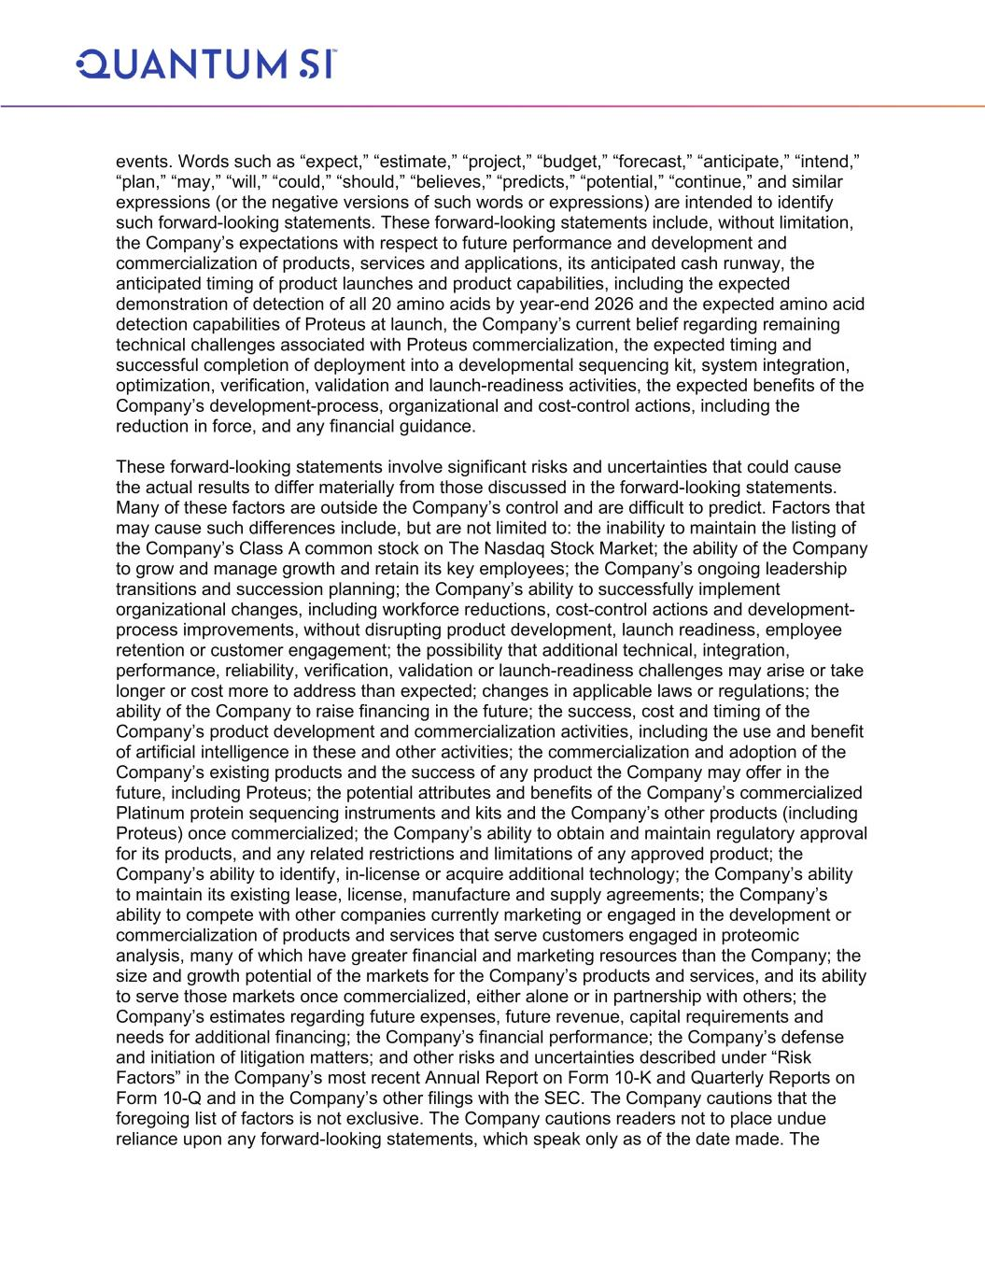
events. Words such as “expect,” “estimate,” “project,” “budget,” “forecast,” “anticipate,” “intend,” “plan,” “may,” “will,” “could,” “should,” “believes,” “predicts,” “potential,” “continue,” and similar expressions (or the negative versions of such words or expressions) are intended to identify such forward-looking statements. These forward-looking statements include, without limitation, the Company’s expectations with respect to future performance and development and commercialization of products, services and applications, its anticipated cash runway, the anticipated timing of product launches and product capabilities, including the expected demonstration of detection of all 20 amino acids by year-end 2026 and the expected amino acid detection capabilities of Proteus at launch, the Company’s current belief regarding remaining technical challenges associated with Proteus commercialization, the expected timing and successful completion of deployment into a developmental sequencing kit, system integration, optimization, verification, validation and launch-readiness activities, the expected benefits of the Company’s development-process, organizational and cost-control actions, including the reduction in force, and any financial guidance. These forward-looking statements involve significant risks and uncertainties that could cause the actual results to differ materially from those discussed in the forward-looking statements. Many of these factors are outside the Company’s control and are difficult to predict. Factors that may cause such differences include, but are not limited to: the inability to maintain the listing of the Company’s Class A common stock on The Nasdaq Stock Market; the ability of the Company to grow and manage growth and retain its key employees; the Company’s ongoing leadership transitions and succession planning; the Company’s ability to successfully implement organizational changes, including workforce reductions, cost-control actions and development- process improvements, without disrupting product development, launch readiness, employee retention or customer engagement; the possibility that additional technical, integration, performance, reliability, verification, validation or launch-readiness challenges may arise or take longer or cost more to address than expected; changes in applicable laws or regulations; the ability of the Company to raise financing in the future; the success, cost and timing of the Company’s product development and commercialization activities, including the use and benefit of artificial intelligence in these and other activities; the commercialization and adoption of the Company’s existing products and the success of any product the Company may offer in the future, including Proteus; the potential attributes and benefits of the Company’s commercialized Platinum protein sequencing instruments and kits and the Company’s other products (including Proteus) once commercialized; the Company’s ability to obtain and maintain regulatory approval for its products, and any related restrictions and limitations of any approved product; the Company’s ability to identify, in-license or acquire additional technology; the Company’s ability to maintain its existing lease, license, manufacture and supply agreements; the Company’s ability to compete with other companies currently marketing or engaged in the development or commercialization of products and services that serve customers engaged in proteomic analysis, many of which have greater financial and marketing resources than the Company; the size and growth potential of the markets for the Company’s products and services, and its ability to serve those markets once commercialized, either alone or in partnership with others; the Company’s estimates regarding future expenses, future revenue, capital requirements and needs for additional financing; the Company’s financial performance; the Company’s defense and initiation of litigation matters; and other risks and uncertainties described under “Risk Factors” in the Company’s most recent Annual Report on Form 10-K and Quarterly Reports on Form 10-Q and in the Company’s other filings with the SEC. The Company cautions that the foregoing list of factors is not exclusive. The Company cautions readers not to place undue reliance upon any forward-looking statements, which speak only as of the date made. The


Company does not undertake or accept any obligation or undertaking to release publicly any updates or revisions to any forward-looking statements to reflect any change in its expectations or any change in events, conditions, or circumstances on which any such statement is based. Investor and Media Contact Jeff Keyes Chief Financial Officer ir@quantum-si.com

